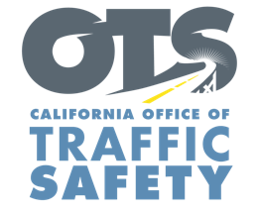
Enter Your Agency Logo

FOR IMMEDIATE RELEASE: December Enter Day, 2021
Enter First Name, Last Name, Email and Phone Number

Don’t Let Drunk, or “High,” Drive: Celebrate the Holiday Season Responsibly
National “Drive Sober or Get Pulled Over” Enforcement Campaign Begins Dec. 15

Enter City, Calif. – This holiday season, Enter Agency Name reminds the public to celebrate the holiday season responsibly by not driving under the influence.

The Enter Agency Name is committed to keeping our community safe and encourages everyone to stay in for the night or use a designated sober driver if you have alcohol, marijuana, prescription, or over-the-counter drugs that may impair.

Delete if not applicable From Dec. 15 through New Year’s Day, Enter Agency Name will have additional officers on patrol looking for drivers suspected of being under the influence of alcohol and/or drugs. The extra enforcement effort is part of a national campaign, Drive Sober or Get Pulled Over, with the goal of stopping suspected impaired drivers who put others on the road at risk.

“When it comes to consuming drugs and/or alcohol and driving, there is a right and wrong choice,” Enter Rank or title, first and last name said. “Make the right choice by not driving impaired so everyone is able to enjoy the holidays.”

Impaired driving is not just from alcohol. Do your research and understand how certain drugs may affect your driving ability.

Delete if not applicable Funding for this program is provided by a grant from the California Office of Traffic Safety, through the National Highway Traffic Safety Administration.



