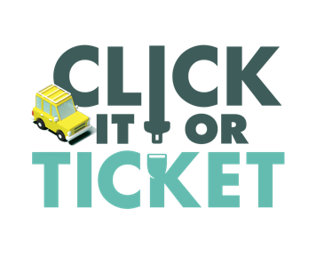
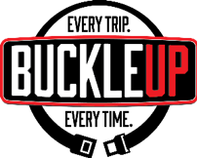
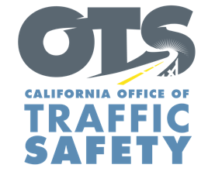

ADD AGENCY LOGO

FOR IMMEDIATE RELEASE: November Enter Day, 2021
CONTACT: Enter Name, Phone Number, E-mail address

Enter City or County Agency Encourages Everyone to Buckle Up for the Thanksgiving Holiday. Every Trip, Every Time.

Enter Your City, Calif. – With millions of families throughout the state expected to hit the road to visit friends and family for Thanksgiving this year, Enter City or County Agency reminds everyone to always buckle up.

“Regardless of how far you are going for Thanksgiving, it is important to always wear your seat belt,” Enter Title or rank, first name, last name said. “We want everyone to get to their destination safely and enjoy the holiday. A seat belt is one easy way to ensure that happens.”

During the 2019 Thanksgiving Maximum Enforcement Period, 42 people died on roads throughout California. Of the 27 who died on roads within California Highway Patrol jurisdiction, 11 were not wearing seat belts.

Delete if not applicable During the Thanksgiving holiday Nov. 24-28 Enter Your Agency will conduct operations Enter any specific dates and times of operations specifically focused on drivers and passengers who are not wearing their seat belt, including children who are not secured in child safety seats.

Under California law, children under two years old who weigh under 40 pounds or are under 40 inches tall must ride in a rear-facing car seat. Children under the age of eight or under 4’ 9” tall must be secured in a car or booster seat.

Delete if not Applicable Funding for this program is provided by a grant from the California Office of Traffic Safety, through the National Highway Traffic Safety Administration.

###

