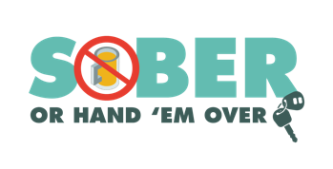
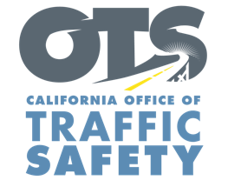
Enter Your Agency Logo
FOR IMMEDIATE RELEASE: November XX, 2021
Enter First Name, Last Name, Email and Phone Number

Be Safe and Drive Sober This Holiday Season

Enter City, Calif. – Millions of us will be traveling to visit friends and family over the holidays. The Enter Agency Name encourages everyone to have a holiday game plan that includes a designated sober driver.

During the pre-Christmas and New Year’s holiday season Nov. 30-Dec. 14, Enter Agency Name will have additional officers on patrol looking for drivers suspected of driving under the influence of alcohol and/or drugs.

Tragically, there is an uptick in impaired drivers during the holidays. During the 2019 Christmas (Dec. 24-Dec. 26) and New Year’s Day (Dec. 28, 2018-Jan. 2, 2019) holiday periods, there were more drunk-driving related deaths (210) throughout the country than during any other holiday period in 2019.

“We want everyone to enjoy the holidays and be safe,” said Enter Title or Rank, First and Last name said. “The more people who plan ahead and find a safe, sober ride home from holiday parties and get togethers, the more the merrier.”
Enter Agency Name reminds drivers that a “DUI Doesn’t Just Mean Booze.” Prescription medications, over-the-counter drugs and marijuana can also impair, especially in combination with alcohol and other drugs.

Delete if not applicable Funding for this program is provided by a grant from the California Office of Traffic Safety, through the National Highway Traffic Safety Administration.


  

