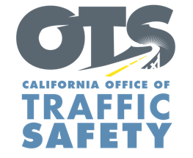
Add Agency Logo

FOR IMMEDIATE RELEASE Enter Month and Day, 2021
Enter First Name, Last Name, Email, Phone Number

Enter Your Agency Name Awarded Grant from the Office of Traffic Safety to Improve Traffic Data Reporting

Enter Your City, Calif. – Enter Your Agency Name received a $Enter Money Amount grant from the California Office of Traffic Safety (OTS) for a traffic records improvement project to enhance the timeliness of reporting crash and citation data.

“Accurate and timely data is critical to understanding the nature of the biggest traffic safety issues in our community and the best ways to address them,” Agency name, title, first and last name. said. “We are grateful for this funding from the OTS, which allows us to report data efficiently and effectively.”

Grant funds will pay for a new electronic crash and citation data reporting system.
Delete any activities that are not part of your grant objectives, Add additional grant objectives not listed

Funding for this program was provided by a grant from the California Office of Traffic Safety, through the National Highway Traffic Safety Administration.

# # #

