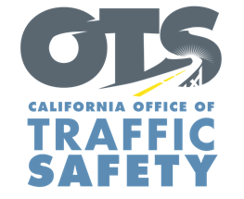
FOR IMMEDIATE RELEASE Enter Month, Day, 2021
Enter First Name, Last Name, Email, Phone

Enter Your Agency Name Awarded Enter $XX Grant Amount Grant From the Office of Traffic Safety

Enter Your City, Calif. – The Enter Agency Name. will roll out a police traffic services program to deter dangerous and illegal driving behaviors that increase the risk of crashes in the community.

“Impairment, speeding and other dangerous driving behaviors jeopardize the safety of other people on the road,” Agency Name, Title or Rank, First and last name said. “This funding allows us to provide necessary traffic enforcement measures with the goal of reducing serious injury and fatal crashes on our roads,” Suggested Quote. Feel free to use your own quote from Police Chief or other Agency Official on benefits and goal of grant

The grant will pay for additional enforcement measures, including: Delete any activities that are not part of your grant objectives, Add additional grant objectives not listed
- DUI checkpoints and patrols specifically focused on suspected impaired drivers.
- Enforcement operations focused on suspected distracted drivers in violation of California’s hands-free cell phone law.
- Bicycle and pedestrian safety enforcement operations focused on driver behaviors that put vulnerable road users at risk.
- Enforcement operations focused on top violations that cause crashes: speeding, failure to yield, stop sign and/or red-light running, and improper turning or lane changes.
- Community education presentations on traffic safety issues such as distracted driving, DUI, speeding, and bicycle and pedestrian safety.
- Collaborative enforcement efforts with neighboring agencies.
- Officer training and/or recertification: Standard Field Sobriety Test (SFST), Advanced Roadside Impaired Driving Enforcement (ARIDE) and Drug Recognition Expert (DRE).

The grant program will run through September 2022.

Funding for this program was provided by a grant from the California Office of Traffic Safety, through the National Highway Traffic Safety Administration.

# # #

