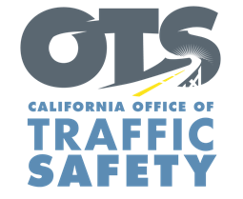
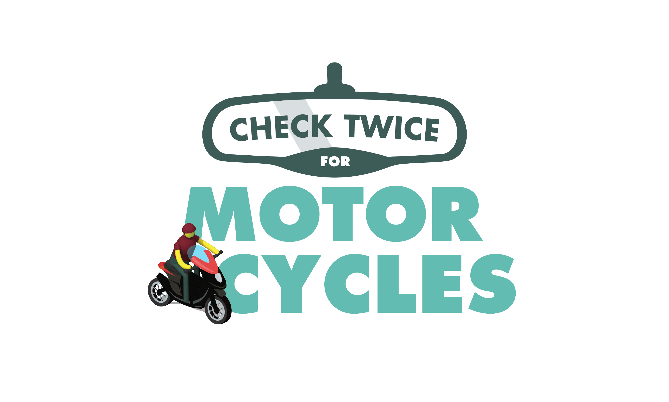

Add Agency Logo

FOR IMMEDIATE RELEASE
Enter Month and Day, 2021
Enter First Name, Last Name, Email

Enter Agency Name Receives Funding for Motorcycle Safety Training Program

Enter Your City, Calif. — The Enter Agency Name received grant funding from the California Office of Traffic Safety (OTS) to step up motorcycle safety awareness with free, hands-on rider trainings.

The Enter $ Amount grant will pay for a series of free motorcycle safety classes that allows riders to practice braking, turning, steering, entering traffic and other skills that help avoid collisions and improve rider safety on the road.

Add Quote about goal of the program and importance of working on riding skills, Enter Agency, rank, first name, last name said.

The motorcycle training program will run through September 2022.

Classes will be available starting Enter Month and/or Date. To register for a free training class, visit Add Link to Registration

Funding for this program is provided by a grant from the California Office of Traffic Safety, through the National Highway Traffic Safety Administration.

  

