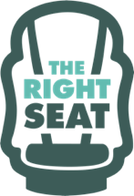
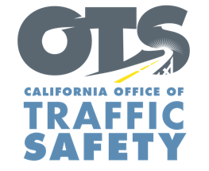
Add Agency Logo

FOR IMMEDIATE RELEASE
Enter Month and Day, 2021
Enter First Name, Last Name, Email, Phone Number

Enter Agency Name Awarded Grant for Child Safety Seat Education Program

Enter Your City, Calif. – Enter Your Agency Name will educate parents and caregivers on how to properly secure children in a safety seat.

The $Enter Funding Amount grant from the California Office of Traffic Safety (OTS) pays for a variety of community outreach events, education classes, and training on the installation and use of child safety seats.

The car seat safety program includes:
- Child safety seat inspection events and education classes.
- Child Passenger Safety Technician (CPST) training and recertification courses.
- Child safety seats at no-cost for families in need.
- Partnering with local organizations on car seat safety community outreach efforts in underserved communities.
Delete or add activities in grant agreement

The program runs through September 2022.

“The OTS grant funding is critical in helping families, caregivers and education professionals keep children safe,” Enter Organization Name, Title, First and Last name said. “Protecting children is everyone’s top priority, and properly secured car seats are one significant way to prevent harm to children in the event of a crash.”

“Like seat belts for teens and adults, correctly installed car seats are the best protection for children while they are traveling,” OTS Director Barbara Rooney said. “Car seat programs are an important traffic safety ally.”

Funding for this program was provided by a grant from the California Office of Traffic Safety, through the National Highway Traffic Safety Administration.

# # #

