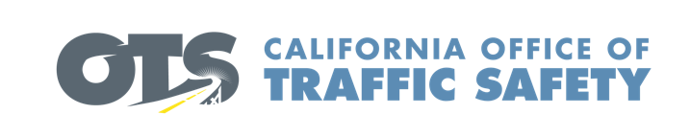

Add Agency Logo

For Immediate Release Enter Month and Day, 2021
Enter First Name, Last Name, Phone and Email

Enter Agency Name Awarded Grant for New Emergency Response Equipment

Enter Your City, Calif. – Enter Agency Name is the recipient of a $Enter dollar amount grant to purchase new extrication equipment. Known as the “jaws of life,” first responders use these specialized tools to safely rescue crash victims trapped inside a vehicle.

“This new equipment will help reduce the time it takes for us to safely reach someone who needs immediate medical attention,” said Enter Agency Name, Rank, First name, Last name. “Without the OTS grant funding, we would not be able to purchase modern rescue tools critical for the care of those injured in crashes.” Suggested quote. Feel free to use own words announcing importance of receiving grant funding and the goal of the grant program

Delays in providing care to crash victims impacts the “golden hour” of survival, a core principle in the emergency medical services industry. Reducing the time it takes to get to the patient, treat what can be treated, and transport the patient to the hospital helps increase the chance for recovery.

Funding for this program was provided by a grant from the California Office of Traffic Safety, through the National Highway Traffic Safety Administration.


  

