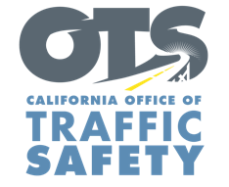

ADD AGENCY LOGO

FOR IMMEDIATE RELEASE Enter Month and Day, 2021

Enter First Name, Last Name, Phone, Email

Enter Agency Name Awarded
Grant from the Office of Traffic Safety for Dedicated Impaired Driving Court Program

Enter your City, Calif. – Enter County Superior Court Name will implement an impaired driving treatment program that specializes in monitoring and rehabilitation services.

The $Enter Grant Dollar Amount grant from the California Office of Traffic Safety (OTS) focuses on high-risk individuals with multiple driving under the influence (DUI) convictions by offering a comprehensive monitoring program that provides the guidance and help needed to reduce repeat DUI offenses.

“This treatment program is a way to focus on the root causes of DUI and offer supportive services that put individuals on track for long-term sobriety,” Enter Agency Name, Title, First and Last Name said.

“Intervention programs are foundational to recovery,” OTS Director Barbara Rooney said. “The best course of treatment comes from helping people turn their lives around, and that is the goal of this program: to guide people in a positive direction.”

The impaired driving court program partners with health care treatment, social services, and other community-based organizations to develop an effective course of treatment for participants through a combination of judicial supervision and other supportive services.

The grant program runs through September 2022.

Funding for this program was provided by a grant from the California Office of Traffic Safety, through the National Highway Traffic Safety Administration.
# # #

