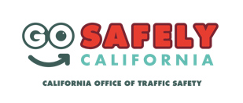
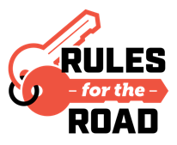
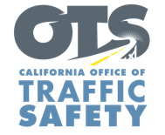
Add Agency Logo
FOR IMMEDIATE RELEASE Enter Month and Day, 2021
Enter Name, Phone Number and Email Address

Enter Agency Name Encourages Parents of Newly Licensed Teens to Discuss the Importance of Safe Driving
National Teen Driver Safety Week is Oct. 17-23

Enter Your City Calif. – As part of National Teen Driver Safety Week Oct. 17-23, Enter Agency Name reminds parents and guardians the importance of talking to their teen(s) about driving responsibly and safely.

Driving remains the most dangerous activity for teens. Per mile driven, teen drivers are nearly four times as likely to be involved in a crash as drivers in all other age groups. According to the Insurance Institute for Highway Safety (IIHS), speeding was a factor in 43% of all teen driver and passenger fatalities from 2015 to 2019, compared to approximately 30% of all traffic deaths among adults 20 and older.

“Like most skills, experience and training make you better and more prepared as a driver,” Agency Name, Title, First and Last name said. “Teen drivers are naturally inexperienced and more likely to take risks and pick up bad habits, which is why it is important for parents and caregivers to play an active role in instilling safe driving habits in their teen.”

Enter Agency Name offers the following tips to parents and guardians for starting conversations about safe driving with teens:
- Provisional Driver’s License : Learn about California’s provisional licensing law, which places restrictions on passengers and driving at night during the first year they have a license.
- Lead by example: Have driving sessions with your teen. Tell, but also show your teen how to drive safely.
- Set ground rules: Be firm on rules such as no phone use, being distracted by friends, always following the speed limit, and always buckling up.
- Sober driving: Emphasize the importance of never driving under the influence or riding with someone who has been drinking.

Delete if not applicable Funding for this program was provided by a grant from the California Office of Traffic Safety, through the National Highway Traffic Safety Administration.
###

