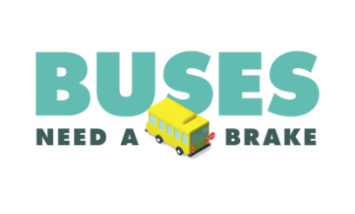
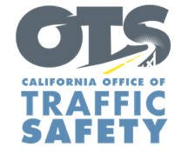
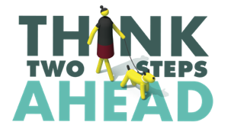
Enter Agency Logo

For Immediate Release Enter Month, Day and Year
Enter First Name, Last Name, Email and Phone Number

It’s Back to School! Enter Your Agency Name Encourages the Public to Stay Aware and Stay Safe in School Zones

Enter Your City, Calif. – As students head back to the classroom, schools and the communities around them are going to be busier than they’ve been since the start of the pandemic.

The Enter Your Agency Name reminds everyone to stay aware and stay safe with increased traffic returning to school zones.

There are going to be a lot more parents, students and staff out than residents have seen in more than a year,” Enter Agency Name, Rank or Title, First Name, Last Name said. “Please drive carefully in school zones, especially during pick-up and drop-off times.”

This includes remembering what to do around school buses.

“The easiest, safest thing to do is to stop the car when you encounter a school bus with a stop sign and flashing red lights,” Enter Rank or Title. Last Name said. “There are going to be students getting on and off the school bus. It’s also the law.”

California law requires drivers to stop when a school bus is in front of them and extends its stop sign with flashing red lights. Drivers must remain stopped if the red lights are on. Drivers in both directions must stop on any two-lane road without a median or a center turn lane.

The Enter Your Agency Name offers the following tips to stay safe around schools:
- Slow down.
- Follow any school rules for dropping off or picking up students.
- Stop for school buses. Watch for children rushing to catch the bus or exiting.
- Whenever possible, avoid blocking the crosswalk while waiting to make a right-hand turn.
- Always look both ways before crossing the street. Make sure cars see you.
- Walk on sidewalks, when available. Cross at marked crosswalks, preferably at stop signs or signals.
- Watch for cars entering or backing out of driveways or leaving parking spaces.

###

