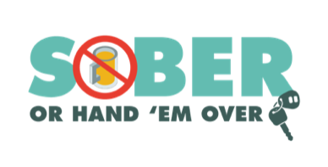
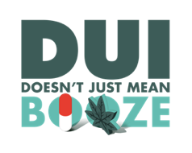
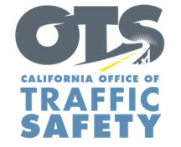
YOUR AGENCY LOGO

FOR IMMEDIATE RELEASE August XX, 2021
Enter Name, phone number and email address

Enter Your Agency Name Encourages the Public to Stay Safe During Final Stretch of Summer Travel Season

Enter your city, Calif. – As friends and family plan vacations during the final days of summer, Type Name of City Police or County Sheriff’s Department is reminding everyone to stay safe by always choosing a sober way to go.

No matter how you choose to celebrate the end of summer and Labor Day weekend, make sure you do so responsibly. Take the necessary precautions to protect yourself and your family by buckling up, ditching the distractions, following the speed limit, and never driving impaired.

To help keep our community safe during the busy late summer and Labor Day weekend travel season, the Type Name of City Police or County Sheriff’s Department will have additional officers on patrol Aug. 18 through Labor Day (Sept. 6) looking for drivers suspected of driving under the influence of alcohol and/or drugs. The increased efforts to address impaired driving are part of a national enforcement campaign, Driver Sober or Get Pulled Over.

Delete if not applicable In addition to roving patrols, Type Name of City Police Department or County Sheriff’s Department will hold a DUI Checkpoint Type Month and Day or dates if holding multiple checkpoints from time in p.m. to time in a.m.at an undisclosed location within the city of Type name of city or county. Add specific location if allowed under department policy. Delete last two sentences if you do not disclose specific location of checkpoints.

“Driving impaired is risky and puts yourself and others around you in serious danger,” name of City Police Department, person’s rank or title followed by first and last name said. “If you are taking a road trip over the next few weeks, make good choices and drive like your closest friends and family are in the cars around you.”

Forty-five people were killed in crashes throughout California over the 2019 Labor Day holiday period, and the California Highway Patrol (CHP) made more than 1,000 arrests for driving under the influence during the 78-hour Labor Day weekend enforcement period alone.

Driving while impaired is not just from alcohol. Prescription drugs, over-the-counter medications and marijuana may also impair. If you plan on drinking or taking medications with a driving warning label, let someone who is sober drive. If you see someone driving impaired, call 9-1-1.

Funding for this program is provided by a grant from the California Office of Traffic Safety, through the National Highway Traffic Safety Administration. Delete this sentence if not applicable.
###

