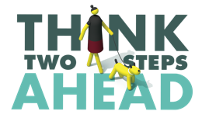
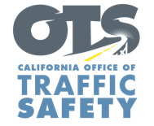
Add Agency Logo

FOR IMMEDIATE RELEASE Enter Month and Day, 2021
Enter Name, Phone Number and Email Address

September is Pedestrian Safety Month: Be Predictable, Look Out for One Another

Enter Your City, Calif. – As part of Pedestrian Safety Month, Enter Agency Name is participating in community-oriented initiatives throughout September to raise awareness about the safety of pedestrians.

Pedestrians are more and more at risk on the road. Based on data from the Governors Highway Safety Association (GHSA), 2020 had the largest ever annual increase, 21 percent, in the rate at which drivers struck and killed pedestrians. In California, pedestrian deaths accounted for 27 percent of all traffic-related deaths in 2019. Another report from GHSA found an overrepresentation in pedestrian deaths of people of color killed in crashes, a disparity that has gotten worse.

“Many people in the community get around by walking,” Enter Agency Name, Title, First and Last Name said. “If you’re driving, please slow down and stop for those attempting to cross the street. If you’re on a walk, be predictable for vehicles. We should all be looking out for one another.”

To promote the safety of those walking, Enter Agency name will host Enter specific dates and details of safety events, including open streets. Delete if not applicable

Enter Agency Name offers actions drivers and pedestrians should take to keep everyone in the community safe, including staying off the phone when behind the wheel or walking:
Pedestrians
- Be predictable. Use crosswalks.
- Take notice of approaching vehicles and practice due care.
- Do not walk or run into the path of a vehicle. No vehicle can stop instantly. At 30 m.p.h., a diver needs at least 90 feet to stop.
- Be visible. Make it easy for drivers to see you – wear light colors, reflective material and carry a flashlight, particularly at dawn, dusk or at night.
- Be extra careful crossing streets or entering crosswalks at night when it is harder to see, or when crossing busier streets with more lanes and higher speed limits.
Drivers
- Follow the speed limit and slow down at intersections. Be prepared to stop for pedestrians at marked and unmarked crosswalks.
- Avoid blocking crosswalks while waiting to make a right-hand turn.
- Never drive impaired.

Delete if not Applicable Funding for this program is provided by a grant from the California Office of Traffic Safety, through the National Highway Traffic Safety Administration.



