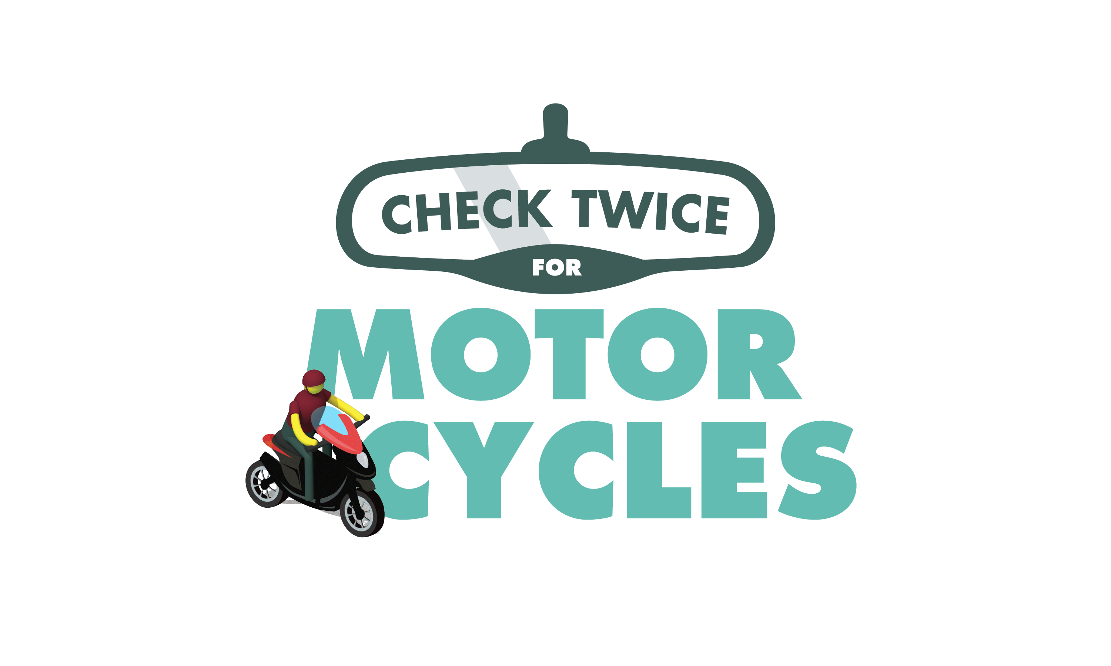

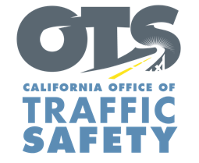
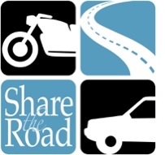
ENTER AGENCY LOGO

FOR IMMEDIATE RELEASE
Enter Month and Day, 2021
Enter First Name, Last Name, Email

Check Twice for Motorcycles: May is Motorcycle Safety Awareness Month

Enter Your City, Calif. — May is Motorcycle Safety Awareness Month, and Enter Agency name reminds drivers to check twice for motorcycles.

“It’s important for drivers to understand motorcycle rider behaviors and learn how to drive safely around riders,” Enter Title, First and Last name said. “Motorcycle riders are more vulnerable and have much less protections as those in vehicles do, which is why it is critical for drivers to be mindful of those on two wheels.”

Delete if not applicable During May’s Motorcycle Safety Awareness Month, Enter agency details about education or enforcement programs

Motorcycle riders are 28 times more likely to die in a crash than vehicle occupants. In 2019, there were 474 motorcycle deaths on California roads.

To help protect you and your family, keep the following tips in mind while driving or riding:

Drivers
- Always check twice for motorcycles, looking at all mirrors and blind spots.
- Motorcycle riders have the same rights to the road as other vehicles. Allow motorcycles to always use the full width of a lane.
- Never follow a motorcycle too closely. Always keep a safe distance.
- If you see a motorcycle with a signal on, be careful. The rider may have forgotten to turn the signal off. Be sure that the rider is turning before proceeding.
Motorcyclists
- Always wear a DOT compliant helmet. Learn how to identify a safe helmet that fits on the National Highway Traffic Safety Administration website.
- Wear appropriate gear like leather clothing, boots with nonskid soles and gloves. Consider adding reflective tape to your clothing to make it easier for other drivers to see you.
- Ride defensively. Don’t assume a driver can see you. Try staying out of a driver’s blind spot.
- Always keep your lights on, even during the day.
- Signal well in advance before changing lanes and watch for turning vehicles.
Lastly, both drivers and riders should never drive/ride under the influence of alcohol and/or drugs.

Delete if not applicable Funding for this program is provided by a grant from the California Office of Traffic Safety, through the National Highway Traffic Safety Administration.

  

