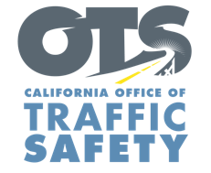
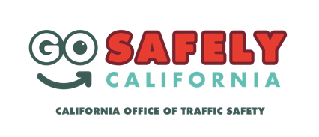
ENTER AGENCY LOGO
FOR IMMEDIATE RELEASE
Enter Month and Day, 2021
Enter First Name, Last Name, Phone Number and Email

May is Bicycle Safety Month: Share the Road and “Go Safely”

Enter City, Calif. — May is National Bicycle Safety Month, and Enter Agency name is encouraging drivers to slow down when passing bicyclists, and asks bicyclists to be visible, predictable, and safe on the road.

“Bicyclists are safest when they act like and are treated the same as drivers,” Enter Title, First Name last name said. “Please share the road with bicyclists and think of them as your closest friends or family. We all want to get where we need to go safely, whether that is in the car or on a bike.”

Enter Agency Name suggests the following safety tips for bicyclists and drivers:
Drivers
- Slow down. Give at least three to five feet of space when passing a bike.
- Wait for a safe place to pass when driving behind a bike, especially on narrow roads. California law requires drivers to provide at least three feet of space between a vehicle and bicycle.
- If making a right turn, assume a bicyclist is traveling through the intersection unless they signal otherwise.
- When making a left turn, yield to oncoming bicyclists just as you would for other drivers.
- Look for cyclists before opening a car door.
- Never drive distracted or impaired.
Bike Riders
- Be predictable, safe, and seen: obey traffic laws, use hand signals, use lights at night (front white light and rear red reflector), and wear a helmet.
- Bicyclists must travel in the same direction of traffic and have the same requirements as any slow-moving vehicle.
- Avoid the door zone: do not ride too closely to parked cars.
- If there’s a bike lane, use it, unless making a left turn, passing, or approaching a place where a right turn is allowed.
- Yield to pedestrians. Bicyclists must yield the right-of-way to pedestrians within marked crosswalks or within unmarked crosswalks at intersections.

Delete if not applicable Funding for this program is provided by a grant from the California Office of Traffic Safety, through the National Highway Traffic Safety Administration.
# # #

