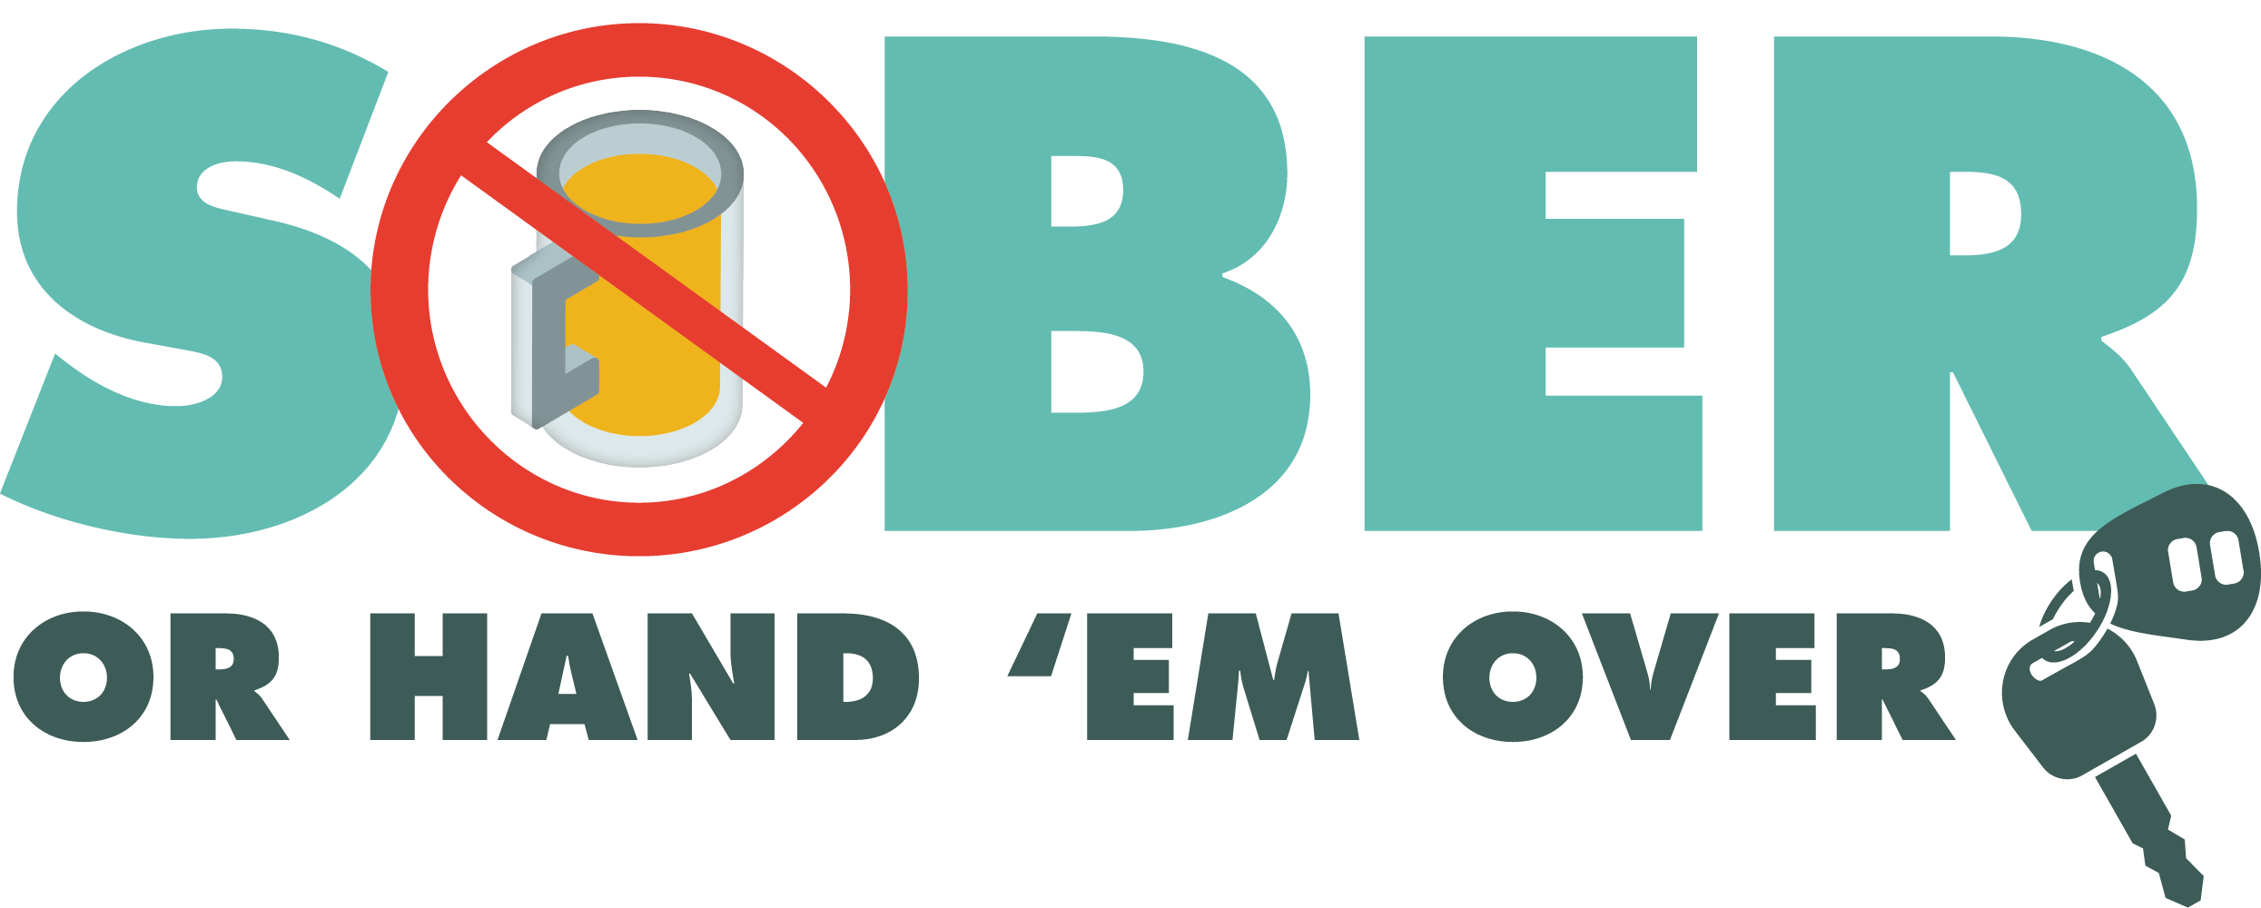
Enter Department Logo & Letterhead
For Immediate Release
Contact: Enter Name, Phone Number and Email

Enter Police/Sheriff’s Department Conducting DUI Patrols

Enter Your City, Calif. - Additional officers from the Enter Your Police/Sheriff’s Department will be out on patrol Enter Date from Enter time p.m. to time p.m./a.m. looking for drivers suspected of driving under the influence of alcohol and/or drugs.

The Enter Police of Sheriff’s Department remains committed to keeping the public safe when they are traveling.

“We want everyone to be as safe as possible, especially when they are on the road,” Enter Rank or title, First Name, Last Name said.

Enter Police of Sheriff’s Department reminds the public that impaired driving is not just from alcohol. Some prescription medications or over-the-counter drugs may interfere with driving. Always follow directions for use and read warning labels about driving. While medicinal and recreational marijuana are legal, driving under the influence of marijuana is illegal.

If you plan on drinking or taking medications that may impact your ability to drive safely, plan on staying at home.

Drivers caught driving impaired and charged with a first-time DUI face an average of $13,500 in fines and penalties, as well as a suspended license.

Delete if not applicable Funding for this program was provided by a grant from the California Office of Traffic Safety, through the National Highway Traffic Safety Administration.

###

