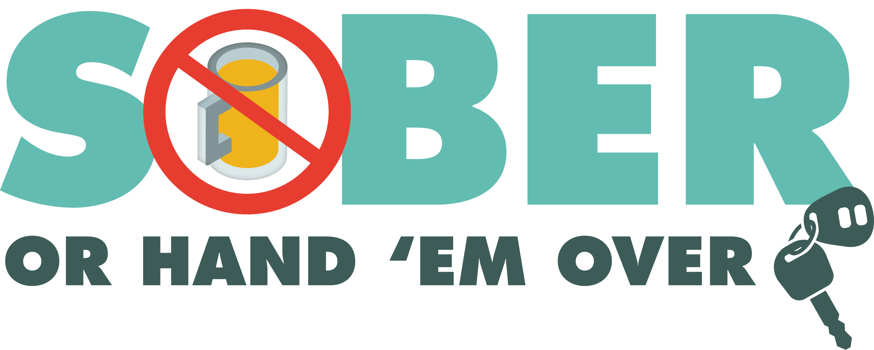
Enter Department Logo & Letterhead
For Immediate Release
Month and Date, 2021

Contact: Enter Name, Phone Number and Email

Enter Department Name Holding DUI Checkpoint Enter Month and Day

Enter Your City, Calif. - Enter Your Police/Sheriff’s Department will hold a DUI Checkpoint Enter Month and Day from Enter time p.m. to Enter time p.m./a.m. at an undisclosed location within Enter City or county limits or add location depending on Department policy. Delete this if not applicable.

Checkpoint locations are chosen based on a history of DUI crashes and arrests. The primary purpose of checkpoints is not to make arrests, but to promote public safety by deterring drivers from driving impaired.

During the checkpoint, officers will look for signs that drivers are under the influence of alcohol and/or drugs.

The Enter Police of Sheriff’s Department is committed to keeping the traveling public safe.

“The safety of our community is and always will be our mission,” Enter Rank or title, First Name, Last Name said. “We are looking for impaired drivers because driving under the influence is dangerous and puts others on the road at risk.”

Enter Police of Sheriff’s Department reminds the public that impaired driving is not just from alcohol. Some prescription medications or over-the-counter drugs may interfere with driving. Always follow directions for use and read warning labels about driving or ”operating heavy machinery,” which includes driving a car. While medicinal and recreational marijuana are legal, driving under the influence of marijuana is illegal.

If you plan on drinking or taking medications that may impact your ability to drive safely, plan on staying at home.

Drivers charged with a first-time DUI face an average of $13,500 in fines and penalties, as well as a suspended license.

Delete if not applicable Funding for this program was provided by a grant from the California Office of Traffic Safety, through the National Highway Traffic Safety Administration.

###

