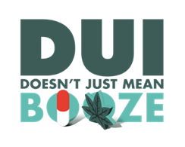
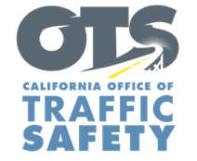
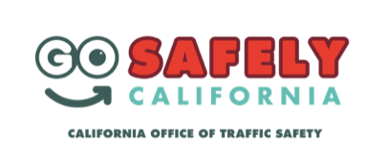
YOUR AGENCY LOGO

FOR IMMEDIATE RELEASE

Contact: Month, Date, 2021
Name, Phone number and email address

Name of Police Department Informs Public How to “Know Your Limit”
Your City, Calif. – On month and date, the Enter Agency Name
will have officers out in the community educating the public on how to monitor their alcohol intake and “know your limit.”

The “Know Your Limit” program is intended to raise awareness about the dangers of drinking and driving, and how little it takes to reach the legal limit to drive a vehicle. It is illegal for anyone 21 or older to drive with a blood alcohol content (BAC) of .08% or higher.

The “Know Your Limit” campaign will be from time in p.m. to time in a.m. in the city of enter city.

During this time, officers will ask patrons how many drinks they have consumed and whether they believe it is safe to drive. Officers will provide information on the impacts of alcohol on one’s ability to drive, and the consequences of a DUI.

“The goal is to help people understand the effects of alcohol so they can make smart decisions about how they get home,” Your City Police Department, officer or deputy rank, first name and last name said. “It only takes a few drinks to impair, and that’s why it is important that people know their limit.”

A person’s height, weight, food intake, drug and/or medication use and how much they drink over a time period are all factors that affect their BAC. According to the California Driver Handbook, it takes two drinks consumed within one hour by a woman between 120-160 pounds and three drinks by a man between 180-220 pounds to be over the legal limit. One drink is based on 1.5 oz. of liquor (40% alcohol), 12 oz. of beer (4.5% alcohol) or a 5 oz. glass of wine (12% alcohol). The BAC lowers at a rate of .01% for every 40 minutes between drinks.

The average cost of a first-time DUI offense is approximately $13,500, accounting for vehicle impound fees, fines, attorney fees, auto insurance hikes and other penalties. Plan ahead and avoid the risk of a DUI by designating a sober driver.

Funding for the “Know Your Limit” program is provided by a grant from the California Office of Traffic Safety, through the National Highway Traffic Safety Administration.
# # #

