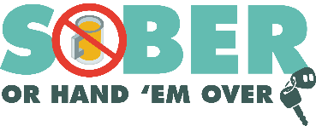
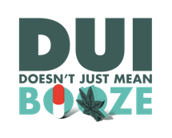
Agency logo/letterhead

FOR IMMEDIATE RELEASE

Enter Month, Day and Year
Enter Contact First Name and Last Name
Enter Phone Number and Email

Say No to Drinking and Driving: Enjoy the Super Bowl at Home This Year

Your City, Calif. – Whether it’s the commercials, halftime show or the game itself, the Enter Your Police or Sheriff’s Department is reminding everyone that we are all on the same team when it comes to being safe on Super Bowl Sunday.

Super Bowl LV is Sunday, Feb. 7, and Enter Your Police or Sheriff’s Department will have additional officers on patrol over the Super Bowl weekend looking for drivers suspected of being under the influence of alcohol and/or drugs.

“If you are watching the game at home and plan to have a drink or two, stay at home Enter Rank or title, First Name, Last Name said. “Have a family member who hasn’t been drinking go out on your behalf or have your food delivered.”

Enter Police of Sheriff’s Department reminds the public that alcohol is not the only thing that impairs and may lead to a DUI. Prescription drugs, over-the-counter medications and marijuana may affect your ability to drive safely. Do your research and understand how a drug affects you before deciding whether or not you are OK to drive.

California’s public health guidance advises to limit mixing with people you don’t live with as much as possible to limit the spread of COVID-19. Although many watch parties will be virtual this year, it’s important to plan ahead, designate a sober driver or simply stay at home for the night.

Delete if not applicable Funding for Super Bowl Sunday enforcement is provided by a grant from the California Office of Traffic Safety, through the National Highway Traffic Safety Administration.
###

