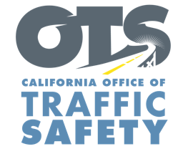
Enter Your Agency Logo

FOR IMMEDIATE RELEASE: December Enter Day, 2020
Enter First Name, Last Name, Email and Phone Number

Be Safe, Be Sober This Holiday Season
National Drive Sober or Get Pulled Over Campaign Begins Dec. 14

Enter City, Calif. – This holiday season, Enter Agency Name wants to remind the public about the importance of being safe and sober when you are driving.

While the COVID-19 pandemic is changing how we celebrate the holidays, the Enter Agency Name is dedicated to keeping the public safe and urges people to stay at home or use a designated sober driver if you plan to drink.

Starting Dec. 14 and through New Year’s Day, Enter Agency Name will have officers on patrol looking for drivers suspected of being under the influence of alcohol and/or drugs. The enforcement effort is part of a national campaign, Drive Sober or Get Pulled Over, intended to show zero tolerance for drunk driving and keep roads safe.

“This year has been challenging and difficult on all of us,” Enter Rank or title, first and last name said. “The last thing we need is more heartbreak and tragedy. Make the right choice by not driving impaired so everyone can have a safe holiday.”

Enter Agency Name reminds the public that impaired driving is not just from alcohol. Prescription medications, over-the-counter drugs and marijuana can also impair, especially in combination with alcohol and other drugs. Do your research and understand how certain drugs you are taking may affect your driving ability.

Due to COVID-19, the state of California is asking residents to avoid large gatherings for the holidays to mitigate the spread of the virus.

Delete if not applicable Funding for this program is provided by a grant from the California Office of Traffic Safety, through the National Highway Traffic Safety Administration.



