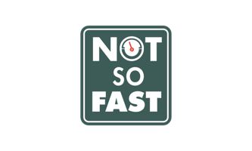
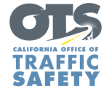
FOR IMMEDIATE RELEASE
Enter First Name, Last Name, Email, Phone Enter Month, Day, 2020

Slow the Fast Down: Public Encouraged to Follow the Speed Limit
Statewide Speeding Campaign Will Run Nov. 16-29

Enter Your City, Calif. – A new statewide initiative encourages drivers to “slow the fast down” and understand the dangers of speeding.

The Enter Agency Name supports efforts by the California Office of Traffic Safety to address an emerging traffic safety issue: speeding.

“We are seeing changes in driving behavior, and the number of people traveling at excessive and extremely dangerous speeds is alarming,” Agency Name, Title or Rank, First and last name. “COVID-19 puts the value of protecting lives in perspective, and practicing safe driving is one simple way everyone can keep themselves and others safe.”

Excessive speeding went way up during the beginning of stay-at-home orders in March. Between March 19 and April 30, CHP officers issued 4,000 citations for speeding over 100 miles per hour, more than double (113%) from last year despite a steep decline in traffic volume Police/Sheriff’s Departments enter local speeding citation data if available.

“The road is not a racetrack,” Rank and last name said. “The freeway is not the Autobahn. Follow a safe, legal speed.”

Speeding remains one of the main causes of crashes: in federal fiscal year 2017-18, speed was a factor in approximately 31% of all fatal and injury crashes in California.

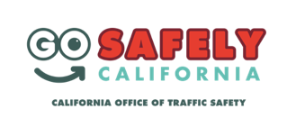
Delete if not applicable Funding for this program was provided by a grant from the California Office of Traffic Safety, through the National Highway Traffic Safety Administration.

###

