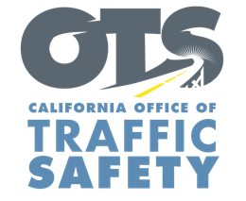
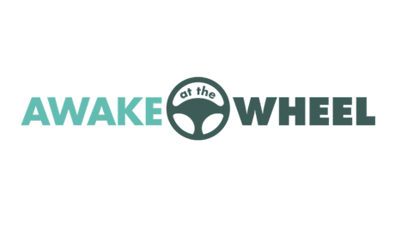
Add Department Logo / Letterhead

For Immediate Release Nov. XX, 2020
Contact: Enter First Name, Last Name, Phone, Email

Stay Awake at the Wheel: Nov. 1-8 is Drowsy Driving Prevention Week

Enter Your City, Calif. – As we “fall back” for Daylight Saving Time beginning Nov. 1, sleep patterns may be disrupted and impact our ability to drive safely.

To highlight the dangers of driving while sleepy or tired, Enter Your Agency Name joins the Office of Traffic Safety and other agencies across the country in recognizing Drowsy Driving Prevention Week, Nov. 1-8, 2020.

“If you are feeling sleepy, it’s best to avoid driving,” Enter Title, First and Last Name said. “Not having enough rest could have a similar impact as drugs or alcohol.”

According to the Centers for Disease Control and Prevention, being awake for at least 24 hours is the same as having a blood alcohol content of .10% percent, which is above the legal limit of .08%.

Enter Your Agency Name offers these tips to avoid drowsy driving:
- Get enough sleep (at least seven hours a day).
- Stick to a consistent sleep schedule.
- Avoid alcohol or medications that can cause drowsiness.
- If traveling long distances, take a break every two hours or 100 miles.
- Take turns with another driver on road trips.
- If you are sleepy, pull over to a safe place like a highway rest area or parking lot and take a 15 to 20-minute nap.

Signs of driver fatigue include frequent yawning, daydreaming, trouble remembering the past few miles driven, missing an exit, or drifting from lanes.

The California Department of Transportation (Caltrans) maintains more than 80 safety roadside rest areas across the state. To find a rest area near you, go to http://quickmap.dot.ca.gov, or download the free QuickMap app on Google Play and in the App Store.




