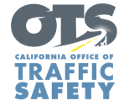
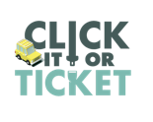
FOR IMMEDIATE RELEASE
Enter First Name, Last Name, Email, Phone Enter Month, Day, 2020

Californians Encouraged to Buckle Up on Every Trip
Nov. 16-29 is Click it or Ticket Seat Belt Enforcement Campaign

Enter Your City, Calif. – Throughout the month of November, the Enter Agency Name is joining agencies across the country promoting the importance of wearing a seat belt in the car and keeping children safe by making sure they are properly restrained.

This year’s Click it or Ticket seat belt enforcement campaign is from Nov. 16-29. During this time, the Enter Agency Name will have additional officers on patrol looking for drivers and passengers who are not wearing a seat belt. This includes drivers who do not properly secure children in child safety seats.

While the seat belt use rate in California was 96% last year, there has been a noted drop in seat belt use by back seat passengers. A recent report by the Governors Highway Safety Association (GHSA) found only 76% of rear seat passengers wore seat belts.

“Wearing a seat belt is your best defense on the road,” Agency Name, Title or Rank, First and last name said. “It only takes a few seconds and helps keep you and your family safe.”

According to the National Highway Traffic Safety Administration (NHTSA), seat belts saved nearly 15,000 lives of people ages five and older in 2017.

The fine for a seat belt violation is $162. California law requires a child be properly secured in a safety seat in the second row of a vehicle, when available, until they are at least 8 years of age. Children under the age of 2 must ride rear-facing or until they reach 40 pounds or 40 inches in height.

California has a primary seat belt law, which allows law enforcement officers to ticket someone for not wearing a seat belt without committing another traffic violation.

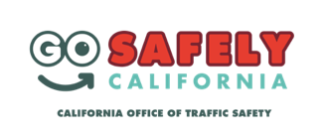
Delete if not applicable Funding for this program was provided by a grant from the California Office of Traffic Safety, through the National Highway Traffic Safety Administration.

###

