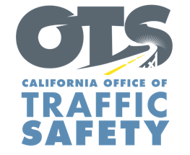
Add Agency Logo

FOR IMMEDIATE RELEASE Enter Month and Day, 2020
Enter First Name, Last Name, Email, Phone Number

Enter Your Agency Name Awarded Grant to Improve Traffic Data Reporting

Enter Your City, Calif. – Enter Your Agency Name received a $Enter Money Amount grant from the California Office of Traffic Safety (OTS) to streamline processes to collect and report traffic data.

“Accurate and timely data is critical to the safety of our roads,” Agency name, title, first and last name. said. “This funding will help paint a clearer picture of our biggest traffic safety issues.”

“This program is new for 2021 and is an effort to improve how quickly crash data is collected and reported,” OTS Director Barbara Rooney said. “High quality safety data is critical. It’s used to determine the nature of our road safety problems and it informs our actions in how best to address them. We are happy to provide local agencies with the necessary tools to develop or enhance their electronic traffic reporting systems.”

Grant funds will be used to:
- Develop a new, or update an existing, electronic crash reporting system with software that is able to submit data to the California Highway Patrol’s Statewide Integrated Traffic Records System (SWITRS).
- Develop an electronic citation system.
Delete any activities that are not part of your grant objectives, Add additional grant objectives not listed

The grant program runs from Oct. 1, 2020 to Sept. 30, 2021.

Funding for this program was provided by a grant from the California Office of Traffic Safety, through the National Highway Traffic Safety Administration.

# # #

