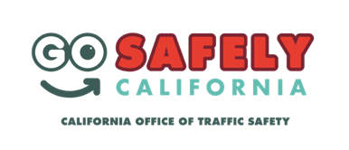
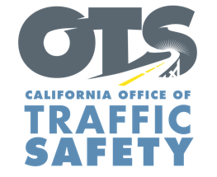
FOR IMMEDIATE RELEASE Enter Month, Day, 2020
Enter First Name, Last Name, Email, Phone

Enter Your Agency Name Awarded Enter $XX Grant Amount Grant From the OTS

Enter Your City, Calif. – The safety of everyone traveling is the focus of a grant awarded to Enter Agency Name. The $Enter Money Amount grant from the California Office of Traffic Safety (OTS) will assist in Enter Agency Name efforts to reduce deaths and injuries on Enter city or county roads.

“These are trying times, and now more than ever, it is important that we are at the forefront of traffic safety,” Agency Name, Title or Rank, First and last name said. “This funding allows us to educate and enhance the safety of all residents.”
Suggested Quote. Feel free to use your own quote from Police Chief or other Agency Official on benefits and goal of grant

The one-year grant is for the 2021 federal fiscal year, which runs from Oct. 1, 2020 to Sept. 30, 2021.

The grant will fund a variety of traffic safety programs, including: Delete any activities that are not part of your grant objectives, Add additional grant objectives not listed
- Patrols with emphasis on alcohol and drug-impaired driving prevention.
- Patrols with emphasis on awareness and education of California’s hands-free cell phone law.
- Patrols with emphasis on education of traffic rights for bicyclists and pedestrians.
- Patrols with emphasis on awareness and education of primary causes of crashes: excess speed, failure to yield, failure to stop at stop signs/signals, improper turning/lane changes.
- Community education presentations on traffic safety issues such as distracted driving, DUI, speed, bicycle and pedestrian safety.
- Collaborative efforts with neighboring agencies on traffic safety priorities.
- Officer training and/or recertification: Standard Field Sobriety Test (SFST), Advanced Roadside Impaired Driving Enforcement (ARIDE) and Drug Recognition Expert (DRE).

“Through education and behavior changes, we hope to create an environment that is safe and equitable for all road users in our community,” Title or Rank, last name said.

Funding for this program was provided by a grant from the California Office of Traffic Safety, through the National Highway Traffic Safety Administration.

# # #

