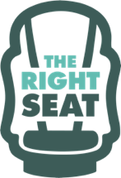
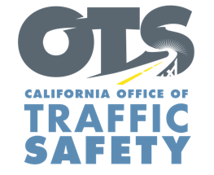
Add Agency Logo

FOR IMMEDIATE RELEASE
Enter Month and Day, 2020
Enter First Name, Last Name, Email, Phone Number

Enter Agency Name Awarded Grant for Child Safety Seat Education Program

Enter Your City, Calif. – Enter Your Agency Name will help parents and caregivers keep their children as safe as possible in the car thanks to a $Enter Funding Amount grant from the California Office of Traffic Safety (OTS).

The one-year grant from Oct. 1, 2020 to Sept. 30, 2021 funds a car seat education program that encourages the proper installation and use of child safety seats.

The grant funds the following activities:
- One-on-one appointments to inspect car seats.
- Child safety seat education classes for parents and caregivers.
- Child safety seats at no-cost to low-income families following education classes.
- Child Passenger Safety Technician (CPST) training, CPST certification courses.
- Work with community partners to promote child passenger safety education.
Delete or add activities in grant agreement

According to the National Highway Traffic Safety Administration (NHTSA), 46% of car seats are misused.

“Add Quote announcing importance of receiving grant funding and goal of the grant program,” Enter Organization Name, Title, First and Last name said.

“Car seats save lives,” OTS Director Barbara Rooney said. “Keeping children safe in a vehicle is as important as ever, and funding for car seat programs play a vital role in ensuring the proper use of child safety seats.”

Funding for this program was provided by a grant from the California Office of Traffic Safety, through the National Highway Traffic Safety Administration.

# # #

