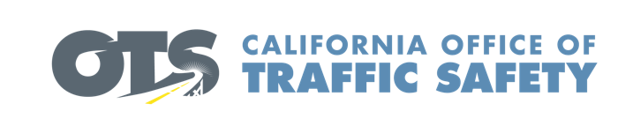

Add Agency Logo

**For Immediate Release**  Enter Month and Day, 2020

Enter First Name, Last Name, Phone and Email

**Enter Agency Name Awarded Grant for New Emergency Response Equipment**

Enter Your City, Calif. – Enter Agency Name was awarded a $Enter dollar amount grant from the California Office of Traffic Safety (OTS) for new extrication equipment. Known as the “jaws of life,” first responders use these specialized tools to reach crash victims trapped inside a vehicle.

So far this year, Enter Your Agency Name has responded to Enter Number of Crashes crashes in which Enter Number of Crashes required extrication.

“The faster we are able to reach someone who is injured, the faster we can get them the help they need,” said Enter Agency Name, Rank, First name, Last name. “New extrication equipment allows us to do just that because they are lighter and easier to operate.” Suggested quote. Feel free to use own words announcing importance of receiving grant funding and the goal of the grant program

“Emergency response is a critical ally for traffic safety,” OTS Director Barbara Rooney said. “This much-needed funding provides first responders with the necessary tools to assist crash victims.”

Delays in extrication can negatively impact the patient’s critical “golden hour” of survival. The “golden hour” for Emergency Medical Services is the core principle of helping individuals with critical injuries: 1) get to the patient quickly, 2) treat what can be treated on scene, and 3) transfer the patient to a hospital. Anything that can be done to reduce each of these time periods aids in recovery and survival.

Funding for this program was provided by a grant from the California Office of Traffic Safety, through the National Highway Traffic Safety Administration.



  