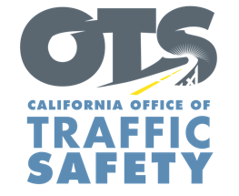
Add Agency Logo

FOR IMMEDIATE RELEASE Enter Month and Day, 2020
Enter First Name, Last Name, Email, Phone Number

Enter Your Agency Name Awarded Grant for Bicycle, Pedestrian Safety Education

Enter Your City, Calif. – Enter Your Agency Name received a $Enter Money Amount grant from the California Office of Traffic Safety (OTS) that focuses on the safety of bicyclists and pedestrians.

Add quote announcing importance of receiving grant funding and the goal of the grant program. Provide agency name, title, first and last name on first reference.

“Our goal is that education will change poor behaviors and make our roads safer,” OTS Director Barbara Rooney said. “This funding will help ensure the safety of those out biking or walking.”

Grant funds will be used for a variety of activities promoting bicyclist and pedestrian safety:
- Education workshops geared toward youth and older adults.
- Education on the importance of safety equipment that improves visibility such as reflective armbands, bicycle headlights and taillights.
- Community walks and bicycle safety courses.
- Bicycle helmet inspections.
- Distribution of bicycle helmets to those in need following education presentations.

The grant program runs from Oct. 1, 2020 to Sept. 30, 2021.

Funding for this program was provided by a grant from the California Office of Traffic Safety, through the National Highway Traffic Safety Administration.

# # #

