YOUR AGENCY LOGO 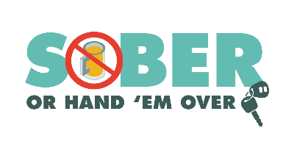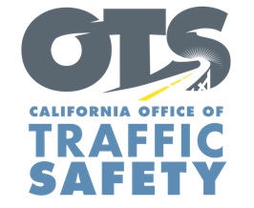

FOR IMMEDIATE RELEASE
Month and Date, 2020
CONTACT:
Name, phone number and email address

Your Actions Save Lives: Celebrate 4th of July Holiday Responsibly

Your City, Calif. – As we approach the 4th of July holiday, the Type Name of Police/Sheriff’s Department encourages the public to be responsible and safe over Independence Day Weekend by not driving impaired.

Many 4th of July events and shows have been canceled due to the COVID-19 pandemic, but more restaurants and bars are now open, making it that much more important for Type Name of Police/Sheriff’s Department to keep the community safe.

July 4th falls on a Saturday this year, and to keep families safe, Type Name of Police/Sheriff’s Department will have extra officers on patrol throughout the Independence Day Weekend looking for drivers suspected of driving impaired.

Delete if not applicable On month and day from time in p.m. to time in a.m., name of Police Department will also be holding a DUI checkpoint at an undisclosed location within the city of the name of your city. Add specific location if allowed under department policy. Delete last two sentences if you do not disclose specific location of checkpoints.

“We are all anxious to get out and return to some sense of normalcy,” name of City Police Department, person’s rank or title followed by first and last name. “But that doesn’t excuse forgetting how to be safe on the road by driving impaired.”

Type Name of City Police Department reminds the public that impaired driving is not just from alcohol. Some prescription medications or over-the-counter drugs may interfere with driving. Always follow directions for use and read warning labels about driving or ”operating heavy machinery,” which includes driving a car. While medicinal and recreational marijuana are legal, driving under the influence of marijuana is illegal.

If you plan on drinking or taking medications that may impact your ability to drive safely, plan on staying at home. If you are going to a bar or restaurant, designate a sober driver before heading out for the evening.

Type Name of City Police Department encourages the community to think of the safety of themselves and their families when enjoying the Independence Day holiday. Your actions save lives.

Funding for DUI enforcement was provided by a grant from the California Office of Traffic Safety, through the National Highway Traffic Safety Administration. Delete this sentence if not applicable.

###

