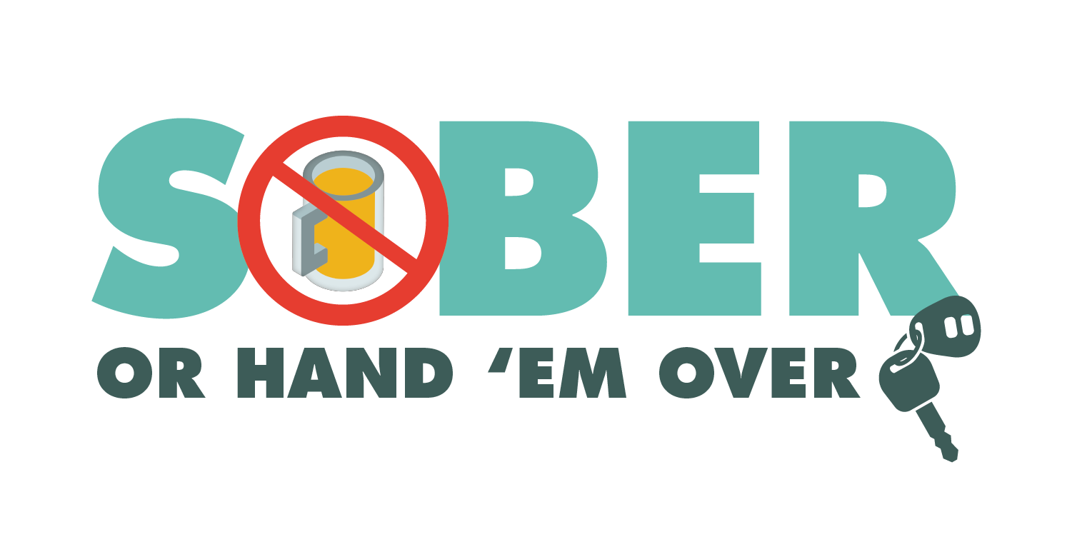

FOR IMMEDIATE RELEASE
Month and Date, 2020
Contact: Enter Names, Phone No., Email Address
Enter Number Arrested or Cited at Enter City or County DUI Checkpoint
Enter Your City, Calif. – Enter number arrested for DUI. If no arrests, highlight any citations issued, such as driving with suspended/revoked license or without a license. while conducting a DUI checkpoint on Enter Date.
The checkpoint was held at Enter street location and nearest intersection from Enter time p.m. to time a.m.
Delete if not applicable Enter number drivers were cited for operating a vehicle unlicensed or with a suspended/revoked license, Enter number vehicles were Enter Number arrested for other criminal charges. Enter specific charges.
Checkpoint locations are based on a history of crashes and DUI arrests. The primary purpose of checkpoints is not to make arrests, but to promote public safety by deterring drivers from driving impaired.
As businesses continue to reopen, including bars and restaurants, impaired driving remains a top traffic safety concern.
Enter Police or Sheriff’s Department will hold another DUI/Driver’s License checkpoint Enter Date. Delete if not applicable.
Funding for this checkpoint was provided by a grant from the California Office of Traffic Safety, through the National Highway Traffic Safety Administration.
###

