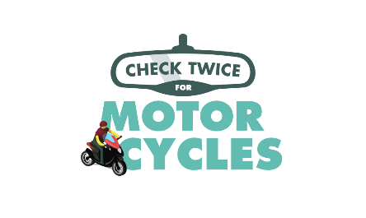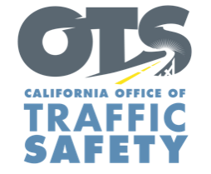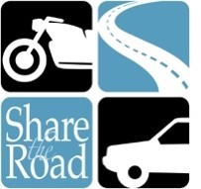
FOR IMMEDIATE RELEASE
Enter Month and Day, 2020
Enter First Name, Last Name, Email

Enter Agency name Conducting Motorcycle Safety Enforcement

Enter Your City, Calif. – Enter Agency name will have extra officers out on patrol Enter Month and Day from Enter time p.m. to p.m. or a.m. to p.m. looking for violations made by drivers and motorcyclists that increase the risk of crashes.

With nearly 900,000 registered motorcycles in the state, many road users are going places without the same protections as drivers. Motorcycle riders are 28 times more likely to die in a crash than vehicle occupants.

To help protect you and your family, keep the following tips in mind while driving or riding:

Drivers
- Always check twice for motorcycles in your mirrors and blind spots.
- Use your signal when changing lanes.
- Never follow a motorcycle too closely. Always keep a safe distance.
- When at an intersection, allow enough space before turning.
Motorcyclists:
- Always wear a DOT compliant helmet and protective gear like gloves and leather clothing.
- Consider adding reflective tape to your clothing to make it easier for other drivers to see you.
- Keep your lights on at all times, even during the day.
- Don’t assume drivers see you: signal well in advance before changing lanes and watch for turning vehicles.
- Although lane splitting is legal, the practice is not encouraged at high speeds in free-flowing traffic, or between large vehicles like big rigs and motor homes.
Delete if not applicable or insert own local health directives regarding COVID-19
The state’s stay-at-home order requires residents to stay at home and only go out to run essential errands or exercise. When out, please remember to practice physical distancing measures when feasible, staying at least six feet apart from others.

Enter Agency name will hold another motorcycle safety enforcement operation Enter Month and Day, delete sentence if not applicable. During these trying times, the safety of the community remains our top priority, and Enter Agency name recognizes the need to protect the public by looking for violations made by drivers and riders that puts the public at further risk.

Delete if not applicable Funding for motorcycle safety enforcement operations are provided by a grant from the California Office of Traffic Safety, through the National Highway Traffic Safety Administration.

  

