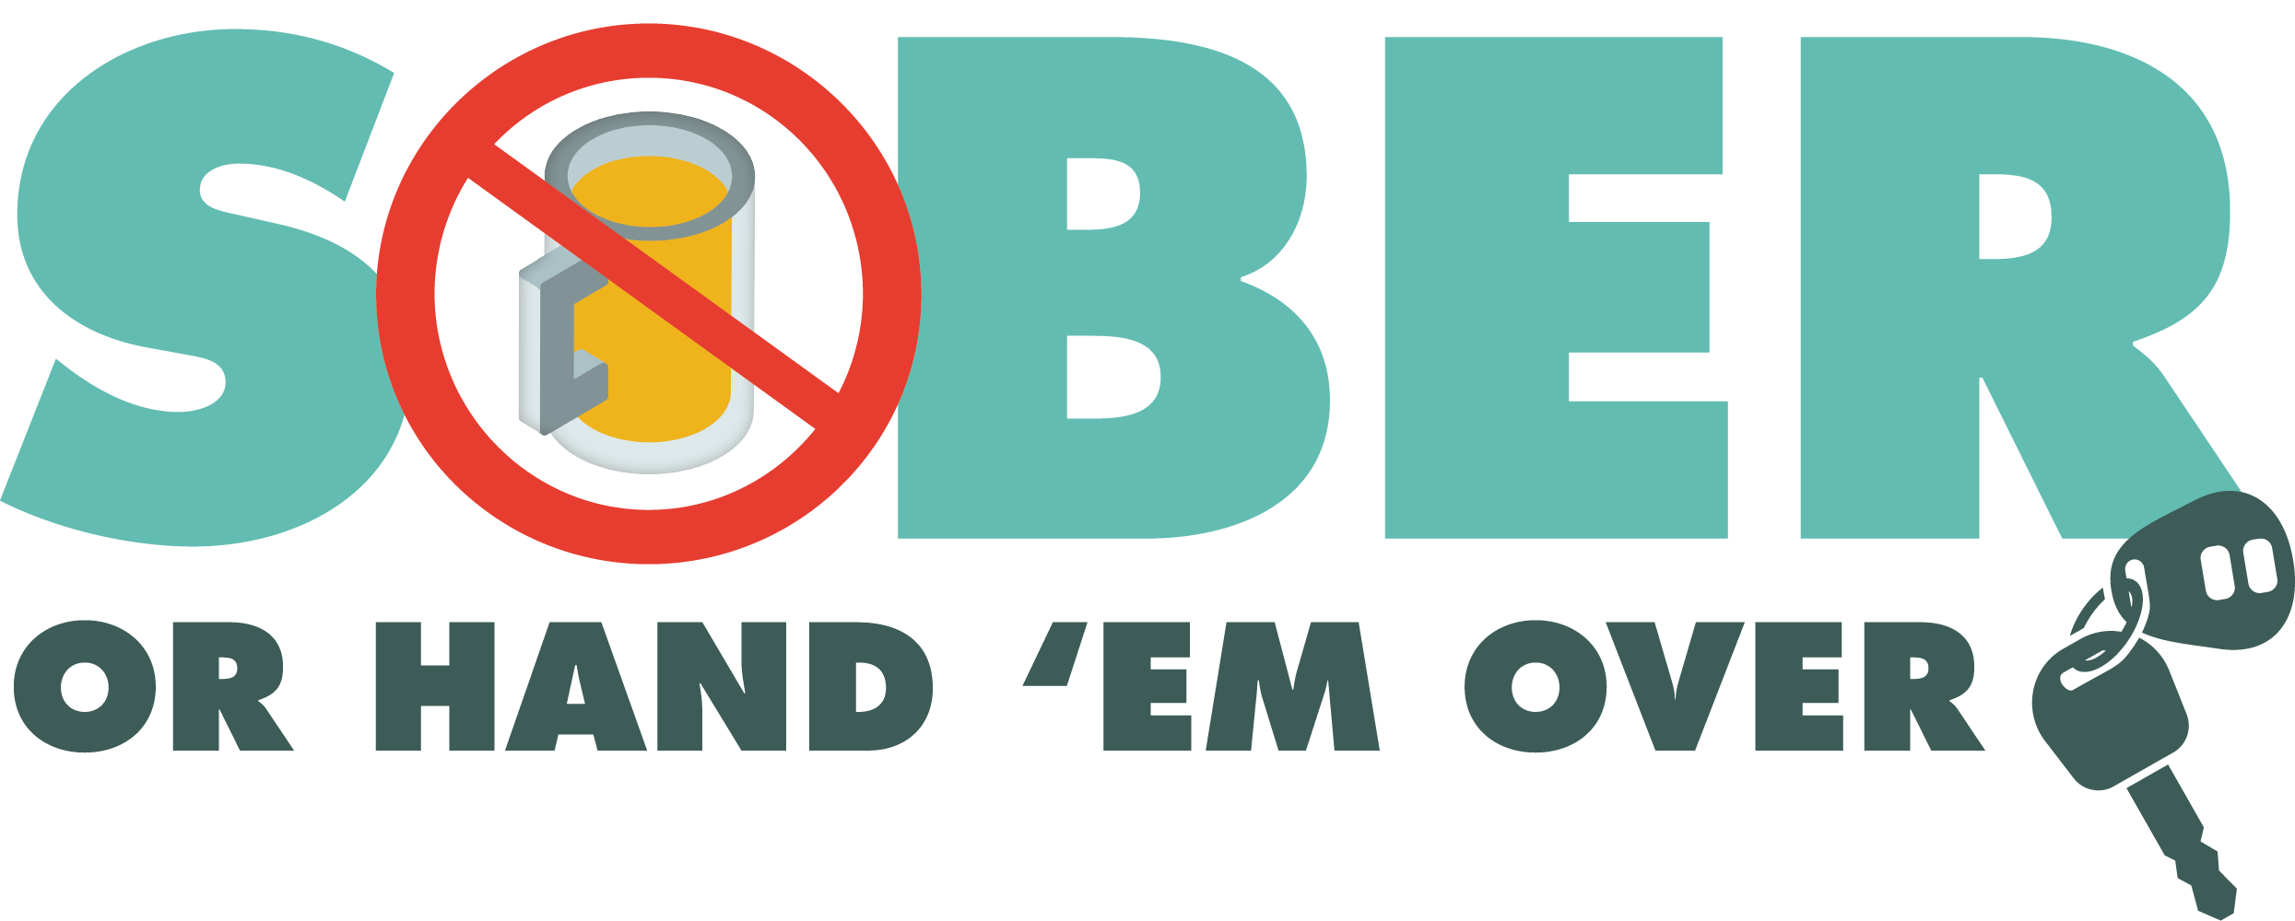
Enter Department Logo & Letterhead
For Immediate Release

Contact: Enter Name, Phone Number and Email

Enter Police/Sheriff’s Department Conducting DUI Patrols

Enter Your City, Calif. - Additional officers from the Enter Your Police/Sheriff’s Department will be out on patrol Enter Date from Enter time p.m. to time p.m./a.m. looking for drivers suspected of driving under the influence of alcohol and/or drugs.

During the COVID-19 pandemic, Enter Police of Sheriff’s Department is committed to keeping the public safe when they need to run essential errands,

“Safety is paramount, but especially during the COVID-19 pandemic,” Enter Rank or title, First Name, Last Name said. “We are all in this together and want everyone to be as safe as possible when they are out. One way to do that is by not driving impaired.”

Enter Police of Sheriff’s Department reminds the public that impaired driving is not just from alcohol. Some prescription medications or over-the-counter drugs may interfere with driving. Always follow directions for use and read warning labels about driving or ”operating heavy machinery,” which includes driving a car. While medicinal and recreational marijuana are legal, driving under the influence of marijuana is illegal.

If you plan on drinking or taking medications that may impact your ability to drive safely, plan on staying at home. Driving sober is your safest bet.

Drivers caught driving impaired and charged with DUI will pay a stiff price: an average of $13,500 in fines and penalties, as well as a suspended license.

Delete if not applicable Funding for this program was provided by a grant from the California Office of Traffic Safety, through the National Highway Traffic Safety Administration.

###

