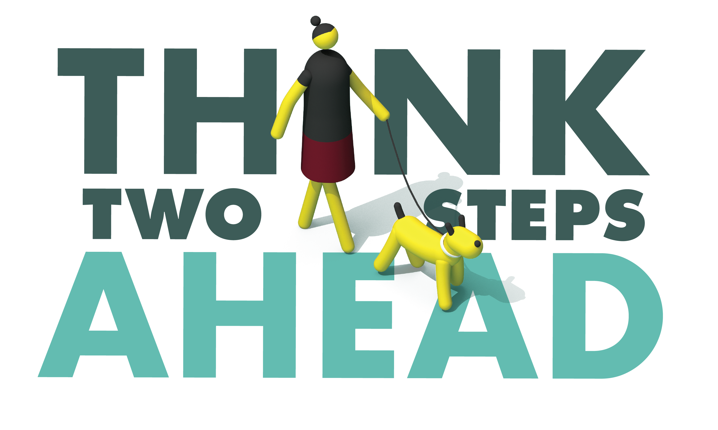

For Immediate Release
Enter First Name, Last Name, Email and Phone Number

Bicycle and Pedestrian Safety Operation Planned for Enter Month and Day

Enter City, Calif. – Enter Agency Name will conduct a bicycle and pedestrian safety enforcement operation Enter date and time from a.m. to p.m. or p.m. to p.m. aimed at keeping people who need to go out to exercise or run essential errands safe.

While the COVID-19 pandemic is requiring residents to stay home as much as possible, the Enter Agency Name recognizes the need to protect the public by looking for violations made by bicyclists, drivers and pedestrians that make roads unsafe.

These violations include drivers speeding, making illegal turns, failing to yield to pedestrians in crosswalks, failing to stop for signs and signals or any other traffic violation. Officers will also look for pedestrians who cross the street illegally or fail to yield to drivers who have the right of way. Bike riders will be stopped when riding on the wrong side of the road, not complying with stop signs and signals, or other violation of the same traffic laws that apply to them as drivers.

“Just because there’s less traffic doesn’t mean traffic rules go out the window,” Enter Title or Rank, First and Last name said. “To protect you and your family, we want to make sure those that are out are following rules intended to keep them safe.”

The safety of bicyclists and pedestrians remains a top priority for the Enter Agency Name. So far this year, Or Enter Year most recent data is available, the Enter Agency Name has investigated Enter number deadly and Enter Number injury collisions involving bicyclists and pedestrians.

To keep you and your family safe, the Enter Agency Name offers the following tips when out biking, driving or walking:

PEDESTRIANS
- Only cross at marked crosswalks or intersections with a stop sign or signal.
- Look for cars backing up. Avoid going between parked cars.
- Make eye contact with drivers. Don’t assume they see you.
- Wear bright clothing during the day and use a flashlight when walking at night.
DRIVERS
- Wait for pedestrians to cross the street. Be courteous and patient.
- Stay off the phone.
- Follow the speed limit.
- Look for pedestrians when backing up or turning.
BICYCLISTS
- Always wear a helmet. Helmets are required by law for anyone under 18.
- Bicyclists must travel in the same direction of traffic and have the same requirements as any slow moving vehicle.

Everyone who is out is reminded to practice physical distancing measures, when feasible, staying at least six feet away from others.

Delete if not applicable Funding for this program is provided by a grant from the California Office of Traffic Safety, through the National Highway Traffic Safety Administration.

# # #

