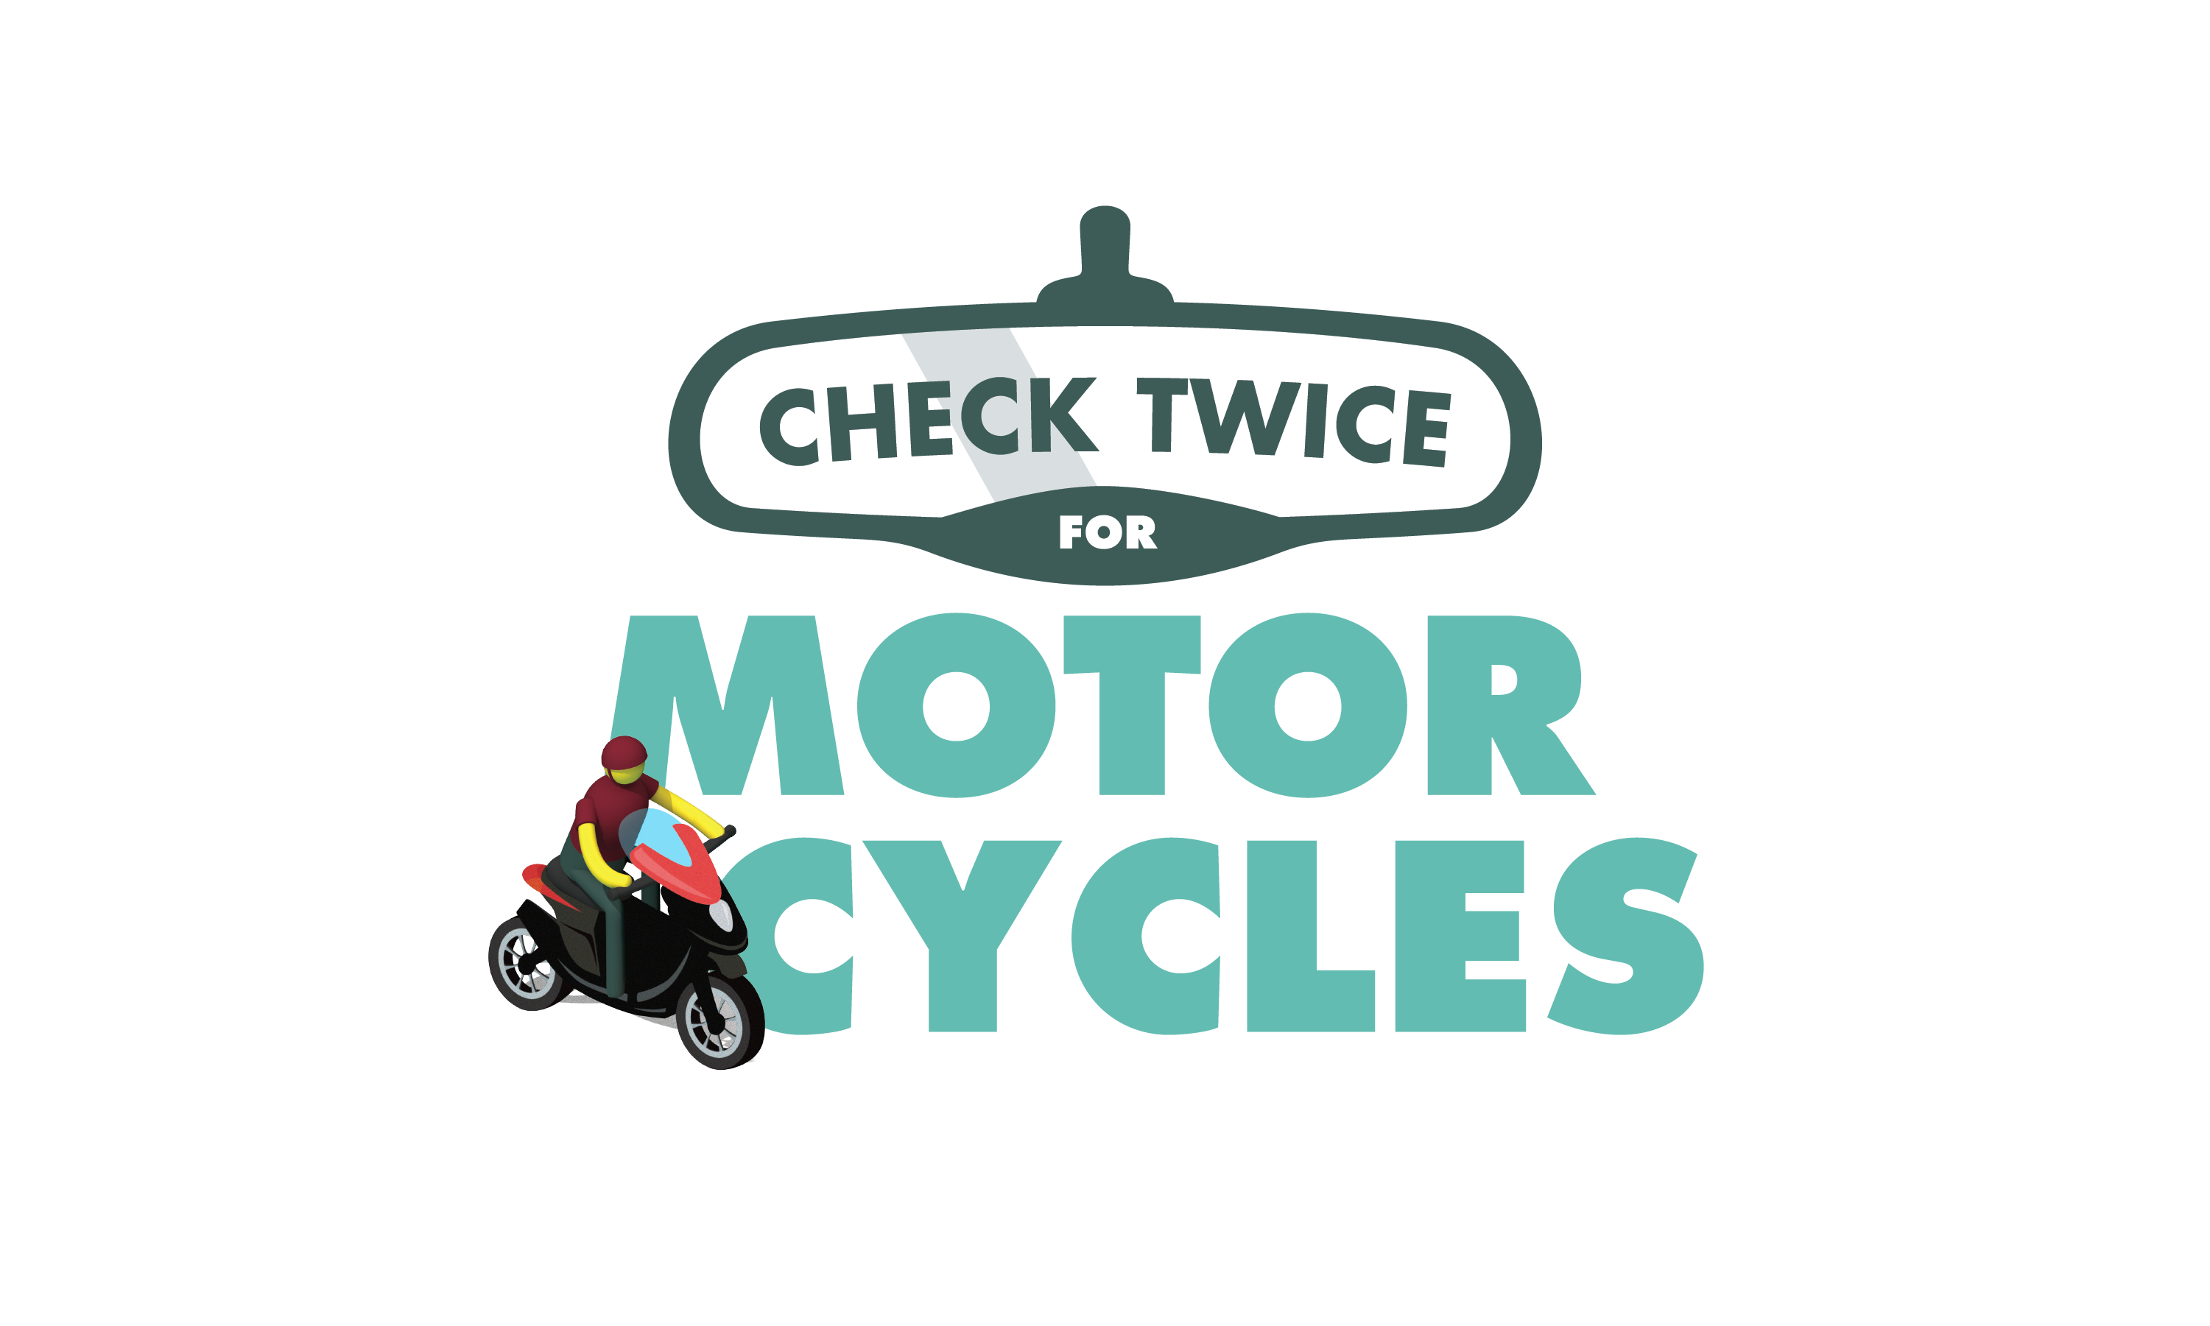

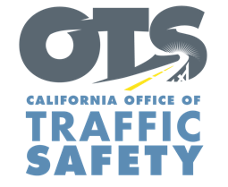
ENTER AGENCY LOGO

FOR IMMEDIATE RELEASE
Enter Month and Day, 2020
Enter First Name, Last Name, Email

All Road Users Are Essential: May is Motorcycle Safety Awareness Month

Enter Your City, Calif. — May is Motorcycle Safety Awareness Month, and Enter Agency name encourages the community to think about the safety of riders on two wheels and look twice for motorcycles.

“While we should be staying at home during the COVID-19 pandemic, we understand people need to get out once in a while and run essential errands,“ Enter Title, First and Last name said. “Don’t let safety on the road go by the wayside, whether you are on two wheels or four.”

Delete if not applicable During May’s Motorcycle Safety Awareness Month, Enter agency details about education or enforcement programs, including approved alternate work plans during the COVID-19 pandemic.

With nearly 900,000 registered motorcycles in the state, many road users are going places without the same protections as drivers. Motorcycle riders are 28 times more likely to die in a crash than vehicle occupants.

To help protect you and your family, keep the following tips in mind while driving or riding:

Drivers
- Always check twice for motorcycles. Both your mirrors and blind spots.
- Use your signal when changing lanes.
- Never follow a motorcycle too closely. Always keep a safe distance.
- When at an intersection, allow enough space before turning.
Motorcyclists:
- Always wear a DOT compliant helmet and protective gear like gloves and leather clothing.
- Consider adding reflective tape to your clothing to make it easier for other drivers to see you.
- Keep your lights on at all times, even during the day.
- Don’t assume drivers see you: signal well in advance before changing lanes and watch for turning vehicles.
Lastly, never drive/ride under the influence of alcohol and/or drugs. Remember, we are all in this together, even if we are told to stay apart.

Delete if not applicable Funding for this program is provided by a grant from the California Office of Traffic Safety, through the National Highway Traffic Safety Administration.

  

