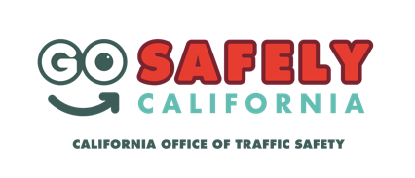
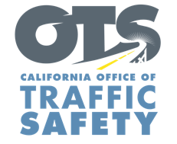
ENTER AGENCY LOGO

FOR IMMEDIATE RELEASE
Enter Month and Day, 2020
Enter First Name, Last Name, Phone Number and Email

Need to run errands or exercise? The rules of the road still apply
Enter Agency Name encourages everyone to “go safely” during National Bicycle Safety Month

Enter City, Calif. — While shelter-in-place orders are in effect, we understand many residents need to run errands or go outside to exercise.

May is Bicycle Safety Month and Enter Agency name is encouraging those out walking, driving or riding their bikes to look out for one another while practicing social distancing measures.

“Biking is a great way to get fresh air and exercise, but keep in mind others are staying at home too and have the same idea,” Enter Title, First Name last name said. “It’s important to keep you and your family safe by remaining aware of your surroundings even though there’s less vehicular traffic.”

Add details of approved alternate education programs to address bicycle safety, including webinars, presentations or other materials available online. Delete if not applicable

Enter agency name suggests the following tips to help keep you and your family safe:
- Always wear a helmet and never ride impaired.
- Follow social distancing measures and maintain at least six feet of physical space between other riders and those out walking.
- Be seen: wear brightly colored clothing and have bike lights handy (front white light and rear red flashing light or reflectors)
- Use hand signals when turning or stopping.
- Rules of the road still apply: Bicyclists must travel in the same direction of traffic and have the same requirements as any slow moving vehicle.
- Keep outside trips to a minimum; they should only be to get essential items or exercise.
Delete if not applicable Funding for this program is provided by a grant from the California Office of Traffic Safety, through the National Highway Traffic Safety Administration.
# # #

