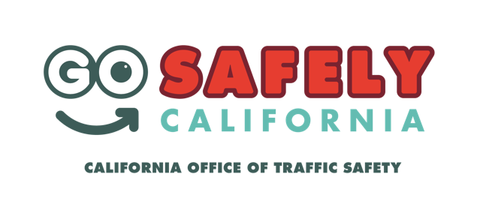
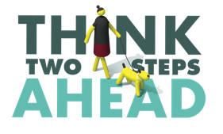
FOR IMMEDIATE RELEASE
Enter Month, Day and Year

Contact: Enter First and Last Name, Title, Email and Phone Number

Enter Number Cited During Pedestrian Safety Enforcement Operation

Enter Your City, Calif. – Enter Your City/County Sheriff’s Department issued Enter number of citations for a variety of violations made by drivers and pedestrians Delete a category (bicyclists, pedestrians or drivers) if no citations were issued during a pedestrian safety enforcement operation on Enter month and date.

The operation took place at Enter locations/intersections of enforcement. Enter city of enforcement if no locations specified from Enter time a.m. to p.m. or p.m. to p.m. Enter number of people who were stopped people were contacted during the operation.

Enter number of drivers drivers were cited for violations including Enter CVC violation types as applicable 21950(a) Driver failure to yield, 21950(c) Unsafe speed at crosswalks, 21979 blocking crosswalk, 22107 Unsafe turn or any other vehicle code violation not listed above. In addition, Enter number of pedestrians cited pedestrians were cited for violations including Enter CVC violation types as applicable 21950(a) Right-of-way at crosswalk; vehicle yield to pedestrian, 21954(a) Pedestrian outside of crosswalks failure to yield, 21955 jaywalking, 647(f)PC Public intoxication or any other vehicle code violation not listed above.

“Our hope is that we educate the public on how to safely get around, whether it is by walking or driving,” Enter Name of Police/Sheriff’s Department Enter Rank, First Name, Last Name said. “Pedestrians should not be afraid of getting hit by a car, and drivers should not be fearful of hitting someone walking. Pedestrian safety is a two-way street.”

The number of crashes involving pedestrians continue to rise at an alarming rate. So far this year, Enter number of pedestrians killed pedestrians have been killed in Enter city or county and another Enter number of pedestrians injured over the same time period.

Enter Name of Police/Sheriff’s Department will be holding another pedestrian safety enforcement operation on Enter Month and Day.

Delete if not applicable Funding for this program was provided by a grant from the California Office of Traffic Safety, through the National Highway Traffic Safety Administration.

###

