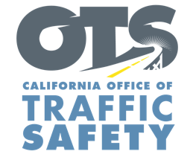
Enter Your Agency Logo

FOR IMMEDIATE RELEASE: December Enter Day, 2019
Enter First Name, Last Name, Email and Phone Number

Drive Sober or Get Pulled Over This Holiday Season
National Enforcement Campaign Through New Year’s

Enter City, Calif. – Enter Agency Name encourages everyone attending holiday parties and gatherings where alcohol may be involved to use a designated sober driver.

This holiday season, from Dec. 13 to New Year’s, Enter Agency Name will have more officers on patrol looking for drivers suspected of being under the influence of alcohol and/or drugs.

Delete if not applicable In addition, Enter Agency Name will hold a DUI/Driver’s License checkpoint Enter Date from Enter time p.m. to time a.m. at an undisclosed location in the city of Enter city.

“Unfortunately, this time of year is when we see more people driving impaired,” Enter Rank or title, first and last name said. “There is no excuse for driving after drinking or using drugs that impair. There are many ways to get home safely without driving.”

Enter Agency Name reminds the public that impaired driving is not just from alcohol. Prescription medications, over-the-counter drugs and marijuana can also impair, especially in combination with alcohol and other drugs.

So if you are hosting a holiday party, offer non-alcoholic drinks for designated sober drivers and monitor how people are getting home. If someone has been drinking and tries to leave, offer to have them stay the night or take ride-share home.

Delete if not applicable Funding for this program is provided by a grant from the California Office of Traffic Safety, through the National Highway Traffic Safety Administration.


  

