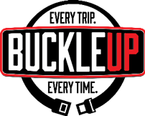
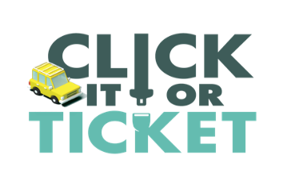
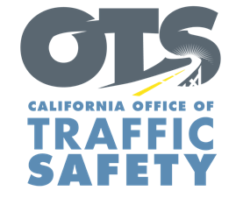

Add Agency Logo

FOR IMMEDIATE RELEASE: Enter Month, Day, 2019

CONTACT:
Enter First Name, Last Name, Phone Number, E-mail address

Enter Your Police Department conducting seat belt enforcement Enter Month and Day

Enter Your City, Calif. – Enter Your Police Department will have additional officers on patrol Enter Month and Day from Enter time a.m. to p.m. or p.m. to p.m. making sure drivers and passengers are wearing their seat belt. Drivers and passengers who do not have a seat belt on will be stopped and ticketed. This also includes drivers who do not secure children in child safety seats.

In California, the fine for a seat belt violation is $162. The fine for not securing a child in a child safety seat is $490.

“Buckling up only takes a few seconds and is the best defense in the event of a crash,” Enter Rank or Title, First Name, Last Name said. “We have seen first-hand the consequences of not wearing a seat belt. This should be a no-brainer, but there are people who still choose to not wear a seat belt, or secure children in the correct car seat.”

In 2018 Or Enter Most Recent Year Data is Available, Enter Number people killed in crashes in the city of Enter your City or County unrestrained. In 2016, 426 people killed in crashes across the state were unrestrained.

Under California law, children under two years old who weigh under 40 pounds or are under 40 inches tall must ride in a rear-facing car seat. Children under the age of eight or under 4’ 9” tall must be secured in a car or booster seat.

Delete if not applicable Funding for this seat belt enforcement operation is provided by a grant from the California Office of Traffic Safety, through the National Highway Traffic Safety Administration.



