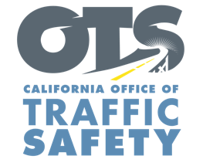
Enter Your Agency Logo

FOR IMMEDIATE RELEASE: November Enter Day, 2019
Enter First Name, Last Name, Email and Phone Number

Buzzed Driving is Drunk Driving: Take a Sober Ride Home This Holiday Season

Enter City, Calif. – Enter Agency Name is reminding everyone who plans to drink to plan on getting a sober ride home.

This holiday season, and every day, the safest way to drive is when you are sober.

To help people get to holiday parties and seasonal travel destinations safely, Enter Agency Name will have extra officers on patrol starting Black Friday (Nov. 29) Or Enter specific date(s) of saturation patrols. Delete if you plan to start enforcement on Black Friday looking for drivers who are suspected of being under the influence of alcohol and/or drugs.

The enforcement efforts are part of a national enforcement campaign to discourage impaired driving from Nov. 29 to Dec. 10.

Delete if not applicable In addition, Enter Agency Name will hold a DUI/Driver’s License checkpoint Enter Date from Enter time p.m. to time a.m. at an undisclosed location in the city of Enter city.

“We want everyone to enjoy the holidays and being responsible plays a major part in that,” said Enter Rank or title, first and last name said. “The danger is clear so before you head out for a party, make sure you have a safe way to get home.”

Alcohol is not the only thing that affects your driving ability. Prescription medications, over-the-counter drugs and marijuana can also impair, especially in combination with alcohol and other drugs.

So if you plan on drinking or taking drugs that can impair, play it safe and have a designated sober driver.

Delete if not applicable Funding for this program is provided by a grant from the California Office of Traffic Safety, through the National Highway Traffic Safety Administration.


  

