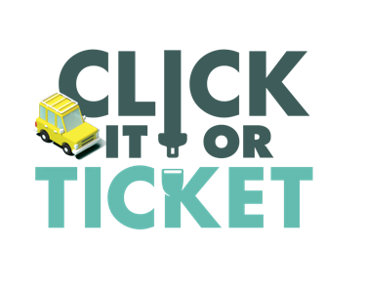
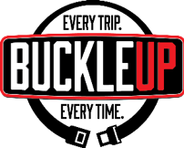
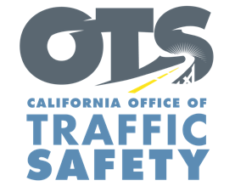

ADD AGENCY LOGO

FOR IMMEDIATE RELEASE: November Enter Day, 2019
CONTACT: Enter Name, Phone Number, E-mail address

Buckle Up, Enter City or County. Every Trip, Every Time.

Enter Your City, Calif. – The Thanksgiving holiday is one of the busiest travel times of the year. Millions across the country will be hitting the road to meet with friends and family for Thanksgiving.

It is why Enter Your Police Department is reminding everyone to wear their seat belt for every trip, regardless of how far you are traveling.

Delete if not applicable On Thanksgiving Day (Nov. 28) or Enter other day of enforcement, Enter Your Police Department will have additional officers on patrol looking for drivers and passengers who do not have a seat belt on, including children who are not secured in the correct child safety seat.

“We want everyone to get to where they are going on Thanksgiving safely,” Enter Title or rank, first name, last name said. “Putting on a seat belt only takes a few seconds and is the best way to put you out of harm’s way.”

While 90% of front seat passengers were observed using seatbelts nationwide, the observed seat belt rate of back seat passengers was just 76 percent, according to the Governors Highway Safety Association. No matter where you are in a vehicle, you should be buckled up.

In California, the fine for a seat belt violation is $162. The fine for not securing a child in a child safety seat is $490.

Under California law, children under two years old who weigh under 40 pounds or are under 40 inches tall must ride in a rear-facing car seat. Children under the age of eight or under 4’ 9” tall must be secured in a car or booster seat.

Delete if not Applicable Funding for this program is provided by a grant from the California Office of Traffic Safety, through the National Highway Traffic Safety Administration.

###

