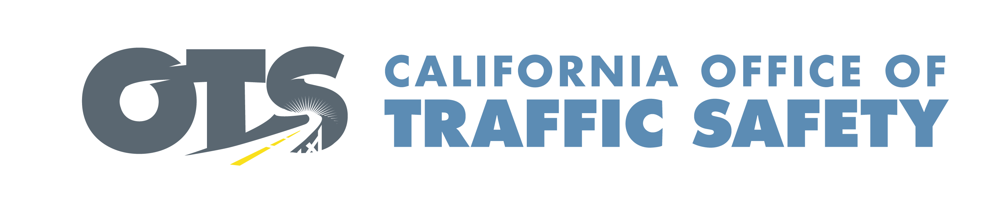
ADD AGENCY LOGO

FOR IMMEDIATE RELEASE September Enter Day, 2019
Enter Contact First and Last Name
Enter Phone Number and Email

One Size Does Not Fit All: Choose the Right Car Seat for Your Child
Sept. 15-21 is Child Passenger Safety Week

Enter Your City, Calif. – Enter Your Organization Name is joining law enforcement agencies, public health departments and other community organizations to raise awareness about the importance of keeping children in the correct car seat for their age and size.

The effort to promote car seat safety coincides with Child Passenger Safety Week, which is from Sept. 15-21.

Enter If Applicable. Delete if not applicable During this time, Enter Your Organization Name will be making sure drivers are securing children in the correct child safety seat. On Enter Dates and Times, Enter Your Organization Name will have Certified Child Passenger Safety Technicians available to show parents and caregivers how to install car seats correctly and assist them in choosing the right car seat for their child.

According to the National Highway Traffic Safety Administration (NHTSA), 46% of car seats are not used properly.

“Children mean the world to parents and caregivers, but unfortunately many are putting them in harm’s way without knowing it,” Enter Title and First, Last Name said. “Our goal is to educate parents and caregivers on how they can keep children riding in the car as safe as possible.”

Child Passenger Safety Week wraps up with National Seat Check Saturday on Sept. 21. Enter Your Organization Name will be hosting a Car Seat Check event from Enter Time a.m. to p.m. or p.m. to p.m. at Enter Location in Enter City. Delete if not applicable.

“Even if you think you have the right car seat and installed it correctly, it doesn’t hurt to get it checked,” Enter Last name said. “We are here to help.”

Under California law, children under two weighing less than 40 pounds and less than 40 inches tall are required to be in a rear-facing car seat. Children under the age of eight or less than 4’ 9” tall must be secured in a car or booster seat. The fine for not securing a child in the correct child safety seat is $490.

To find the right seat for your child, visit the NHTSA website. To find a car seat fitting station near you, contact your local CHP area office or go to the California Office of Traffic Safety website for a listing of car seat programs statewide.

Delete if not applicable Funding for this child passenger safety program is provided by a grant from the California Office of Traffic Safety, through the National Highway Traffic Safety Administration.
# # #

