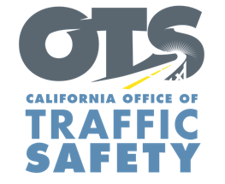
Add Agency Logo

FOR IMMEDIATE RELEASE: Enter Month and Day, 2019
Enter First Name, Last Name, Email, Phone Number

Enter Agency Name Awarded Grant for Child Passenger Safety Education Program

Enter Your City, Calif. – Enter Your Agency Name announced today a $Enter Funding Amount grant has been awarded by the California Office of Traffic Safety (OTS) to fund programs that educate parents and guardians on child passenger safety. The grant is for a one-year period from Oct. 1, 2019 to Sept. 30, 2020.

Grant funding will be used for a variety of activities to promote the proper use of child safety seats:
- Car seat checkup events and/or one-on-one appointments to inspect car seats.
- Child safety seat education classes informing parents on using and properly installing the right car seat based on a child’s height and weight.
- Child Passenger Safety Technician (CPST) training, CPST certification/recertification courses.
- Distribution of child safety seats to families in need.
- Surveys on car and booster seat compliance rates.
- Community events and fairs to increase awareness about child passenger safety.
Delete or add activities in grant agreement

Enter Quote from Health Director, Police Chief or other official on benefits of grant and goal of grant
Car crashes remain the leading cause of death for children 13 and under. According to the National Highway Traffic Safety Administration (NHTSA), 46% of car seats are not used properly.

“Children should be as safe as possible when traveling in a car,” OTS Director Barbara Rooney said. “Funding for child passenger safety education and training allows our partners to make sure children are in the right car seat that is being used correctly.”

Funding for this child passenger safety program was provided by a grant from the California Office of Traffic Safety, through the National Highway Traffic Safety Administration.


  

