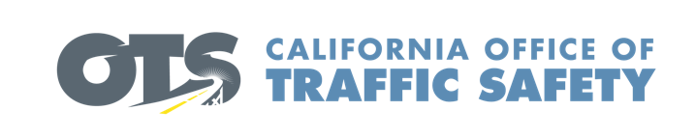

Add Agency Logo

For Immediate Release Enter Month and Day, 2019
Enter First Name, Last Name, Phone and Email

Enter Agency Name awarded grant to buy new emergency response equipment

Enter Your City, Calif. – Enter Agency Name was awarded a $Enter dollar amount grant from the California Office of Traffic Safety (OTS) for the purchase of new extrication equipment that will be used to rescue crash victims. Known as the “jaws of life,” first responders use these rescue tools to break apart a wrecked vehicle with victims trapped inside. The tools help reduce the time it takes to rescue and treat crash victims.

So far this year, Enter Your Agency Name has responded to Enter Number of Crashes crashes in which Enter Number of Crashes required extrication.

“This newer equipment is lighter and easier to use, allowing us to rescue victims faster, which ultimately increases their chances of survival,” said Enter Agency Name, Rank, First name, Last name. “In many cases, even minutes without treatment can be a matter of life and death, which is why it is important to have reliable equipment that allows first responders to provide care as quickly as possible.”

Delays in extrication can negatively impact the patient’s critical “golden hour” of trauma survivability. The “golden hour” for Emergency Medical Services is the core principle of rapid intervention in trauma cases: 1) get to the patient quickly, 2) treat what can be treated on scene, and 3) quickly get the patient to the right hospital. Anything that can be done to reduce each of these time periods aids in patient survival and recovery.

Funding for this program was provided by a grant from the California Office of Traffic Safety, through the National Highway Traffic Safety Administration.


  

