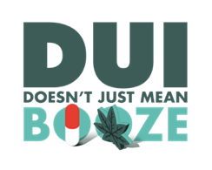
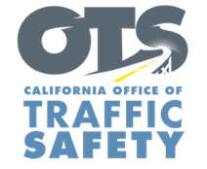
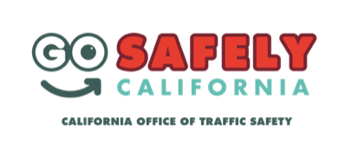
YOUR AGENCY LOGO

FOR IMMEDIATE RELEASE
Contact: Month, Date, 4-digit year
Name, Phone number and email address

Name of Police Department Conducting “Know Your Limit” Education Program On Month Date
name of your city, Calif. – On month and date, the your city Police Department will have officers out at local bars and restaurants to educate the public on how important it is to “know your limit.”

The “Know Your Limit” program is intended to inform the public on how little it takes to reach the legal limit for blood alcohol content (BAC), which is .08% in all states but Utah, where the BAC is .05%.

The campaign will be from time in p.m. to time in a.m. in the city of enter city. During this time, officers will invite volunteers to take a breathalyzer test to see if they can guess their BAC. Those participating are asked how many drinks they had and whether they believe they are safe to drive. Following the test, officers educate those out drinking on the impacts of alcohol on one’s ability to drive, and the consequences of a DUI.

“The goal is to help people understand the effects of alcohol so they can make smart decisions about how they get home after a night of drinking,” Your City Police Department, officer or deputy rank, first name and last name said. “It only takes a few drinks to impair, and that’s why it is so critical that people know when not to drive.”

A person’s height, weight, food intake, drug and/or medication use and how much they drink over a time period are all factors that affect BAC. According to the Texas Alcoholic Beverage Commission, it takes two drinks consumed within one hour by a 120-pound woman and four drinks by a 180-pound man to be at the legal limit. One drink is based on 1.5 oz. of liquor (40% alcohol), 12 oz. of beer (4.5% alcohol) or a 5 oz. glass of wine (12% alcohol). The body lowers your BAC at a rate of .015% every hour.

The average cost of a DUI arrest is approximately $13,500, accounting for vehicle impound fees, fines, attorney fees, auto insurance hikes and other penalties. Plan ahead and avoid risking a DUI by designating a sober driver.

Funding for the “Know Your Limit” program is provided by a grant from the California Office of Traffic Safety, through the National Highway Traffic Safety Administration.

# # #

