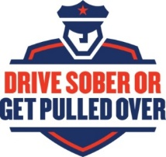
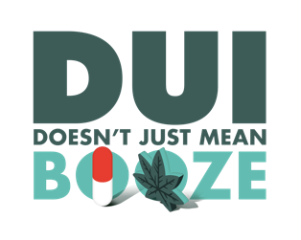
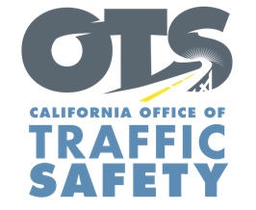
YOUR AGENCY LOGO

FOR IMMEDIATE RELEASE August XX, 2019
CONTACT:
Name, phone number and email address

Your Police Department Encourages Public to be Responsible and Drive Sober

Name of your city, Calif. – As summer comes to a close, Type Name of City Police or County Sheriff’s Department is asking drivers to not get behind the wheel after drinking or using drugs that impact your ability to drive safely.

Type Name of City Police Department or County Sheriff’s Department is joining law enforcement agencies across the country in the national enforcement campaign, Drive Sober or Get Pulled Over. During this period, which runs from Aug. 16 to Sept. 2 (Labor Day), Type Name of City Police Department or County Sheriff’s Department will have additional officers on the road looking for drivers suspected of driving under the influence of alcohol and/or drugs.

Delete if not applicable: In addition to patrols, Type Name of City Police Department or County Sheriff’s Department will hold a DUI/Driver’s License Checkpoint Type Month and Day from time in p.m. to time in a.m. at an undisclosed location within the city of Type name of city. Add specific location if allowed under department policy. Delete last two sentences if you do not disclose specific location of checkpoints.

Labor Day Weekend remains one of the deadliest times of year for alcohol-involved crashes. According to the National Highway Traffic Safety Administration, there were 376 deadly crashes nationwide during the 2017 Labor Day holiday period (Sept. 1 to Sept. 5). Among those crashes, more than one-third (36%) involved a drunk driver. Last year, two people were killed, and 31 others injured in California on Labor Day alone.

“There are so many ways to get home safely without driving,” name of City Police Department, person’s rank or title followed by first and last name said. “Driving while drunk or high is dangerous, irresponsible and causes too many senseless tragedies. We hope that drivers get the message that driving impaired will never be tolerated.”

Driving while impaired is illegal, whether it is alcohol, prescription drugs, over-the-counter medications or marijuana.

If you plan on drinking or are taking medications that can affect your driving ability, designate a sober driver or use a ride-share service. If you see someone driving impaired, call 911.
Funding for DUI enforcement is provided by a grant from the California Office of Traffic Safety, through the National Highway Traffic Safety Administration. Delete this sentence if not applicable.
###

