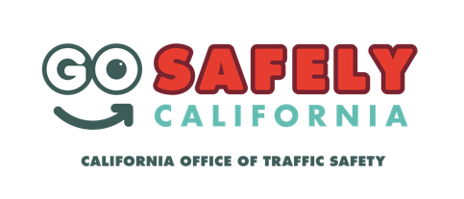
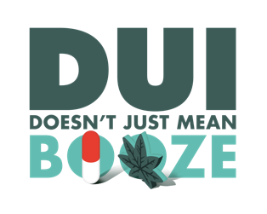
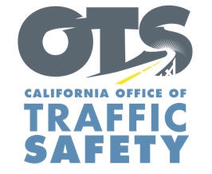
YOUR AGENCY LOGO

FOR IMMEDIATE RELEASE Month and Date, 2019
CONTACT:
Name, phone number and email address

Drive Sober or Get Pulled Over This 4th of July Holiday
Name of your city, Calif. – The 4th of July holiday is a time to enjoy fireworks and show country pride but is also traditionally one of the more dangerous times on the road.

To keep families safe this Independence Day, Type Name of City Police Department will have increased enforcement focused on impaired driving during the 4th of July holiday. Add date and time of enforcement if done on specific day and time.

Delete if not applicable: On month and date from time in p.m. to time in a.m., name of City Police Department will be holding a DUI/Driver’s License checkpoint at an undisclosed location within the city of the name of your city. Add specific location if allowed under department policy. Delete last two sentences if you do not disclose specific location of checkpoints.

According to preliminary data from the California Highway Patrol, seven people were killed and 73 injured in alcohol-related crashes statewide on fourth of July last year. Every deadly crash involved a driver who had been drinking.

“Drinking and driving is a bad combination,” name of City Police Department, person’s rank or title followed by first and last name said. “The consequences are abundantly clear, yet people still make the poor decision to drive after drinking. Please be smart and make this 4th of July holiday a fun and memorable one.”

If you are headed to 4th of July parties, designate a sober driver before heading out for the evening. If you are hosting a party, offer nonalcoholic drinks for designated sober drivers and monitor who is drinking. See people leaving who have been drinking? Check how they are getting home. Offer to let them stay the night if a sober driver is not available to take them home.

“Driving with just a buzz doesn’t cut it,” Officer, Deputy or other rank and last name said. “With the rise in ride-share options, there really is no excuse for driving impaired.”

The average cost of a DUI arrest is approximately $13,500, accounting for vehicle impound fees, fines, attorney fees, auto insurance hikes and other penalties. Name of city Police Department also reminds residents that prescription drugs, over-the-counter medications and marijuana can all be impairing and land you a DUI, especially in combination with alcohol and/or other drugs.

Funding for DUI enforcement was provided by a grant from the California Office of Traffic Safety, through the National Highway Traffic Safety Administration. Delete this sentence if not applicable.

###

