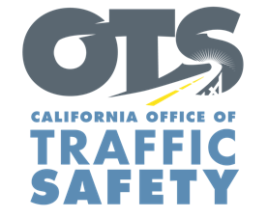
Your Agency
Logo Here

FOR IMMEDIATE RELEASE: Month, XX, 2019

CONTACT: Name, Phone Number, E-mail address

[Your] Police Department conducting seat belt enforcement [Date]

The [Your] Police Department will have additional officers on patrol [Date] from xx:xx [a.m. or p.m.] to xx:xx [a.m. or p.m.] making sure drivers and passengers are wearing their seat belt. Drivers and passengers who do not have a seat belt on will be stopped and ticketed. This also includes drivers who do not secure children in child safety seats.

In California, the fine for a seat belt violation is $162. The fine for not securing a child in a child safety seat is $490.

“Buckling up only takes a few seconds and is the best defense in the event of a crash,” [Rank and Name] said. “We have seen first-hand the consequences of not wearing a seat belt. This should be a no-brainer, but there are people who still choose to not wear a seat belt, or secure children in the correct car seat.”

In 2018 [or most recent year available], ## people killed in crashes in the city of [Your City] were unrestrained. In 2016, 426 people killed in crashes across the state were unrestrained.

Under California law, children under two years old who weigh under 40 pounds and are under 40 inches tall must ride in a rear-facing car seat. Children under the age of eight or under 4’ 9” tall must be secured in a car or booster seat.

<< If Applicable >> Funding for this seat belt enforcement operation is provided by a grant from the California Office of Traffic Safety, through the National Highway Traffic Safety Administration. <<If Applicable>>




