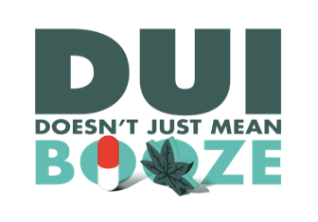
Agency Letterhead

PRESS RELEASE

FOR IMMEDIATE RELEASE: [Date]

Contact: Names, Phone No., Email Address

[##] Arrested During DUI Saturation Patrol

Your City, Calif. – [Your] Police Department arrested [##] on suspicion of DUI [or other charge] [or other significant details if no arrests. Can mention there were no arrests.] while conducting a DUI Saturation Patrol on [Date].

<<If applicable>> In addition, [Your] Police Department made [##] vehicle enforcement stops and cited [##] drivers for operating a vehicle without a license or on a suspended/revoked license.

Last year [or most recent data available] [Your] Police Department [or Sheriff’s Department/Office] investigated ### DUI collisions that killed # people and injured # others.

Drivers caught driving impaired and charged with DUI can expect the impact of a DUI arrest to be approximately $13,500. This includes fines, fees, DUI classes, license suspension and other expenses not to mention possible jail time.

[Your Police or Sheriff’s] Department reminds drivers that “DUI Doesn’t Just Mean Booze.” Prescription drugs, particularly those with a driving or operating machinery warning on the label, can impair and result in a DUI. Marijuana can also be impairing, especially in combination with alcohol or other drugs.

[Your] Police [or Sheriff’s] Department will be conducting another DUI/Driver’s License Checkpoint and/or DUI saturation Patrol on [Date and Time].

Funding for this DUI Saturation Patrol was provided by a grant from the California Office of Traffic Safety, through the National Highway Traffic Safety Administration.

###

