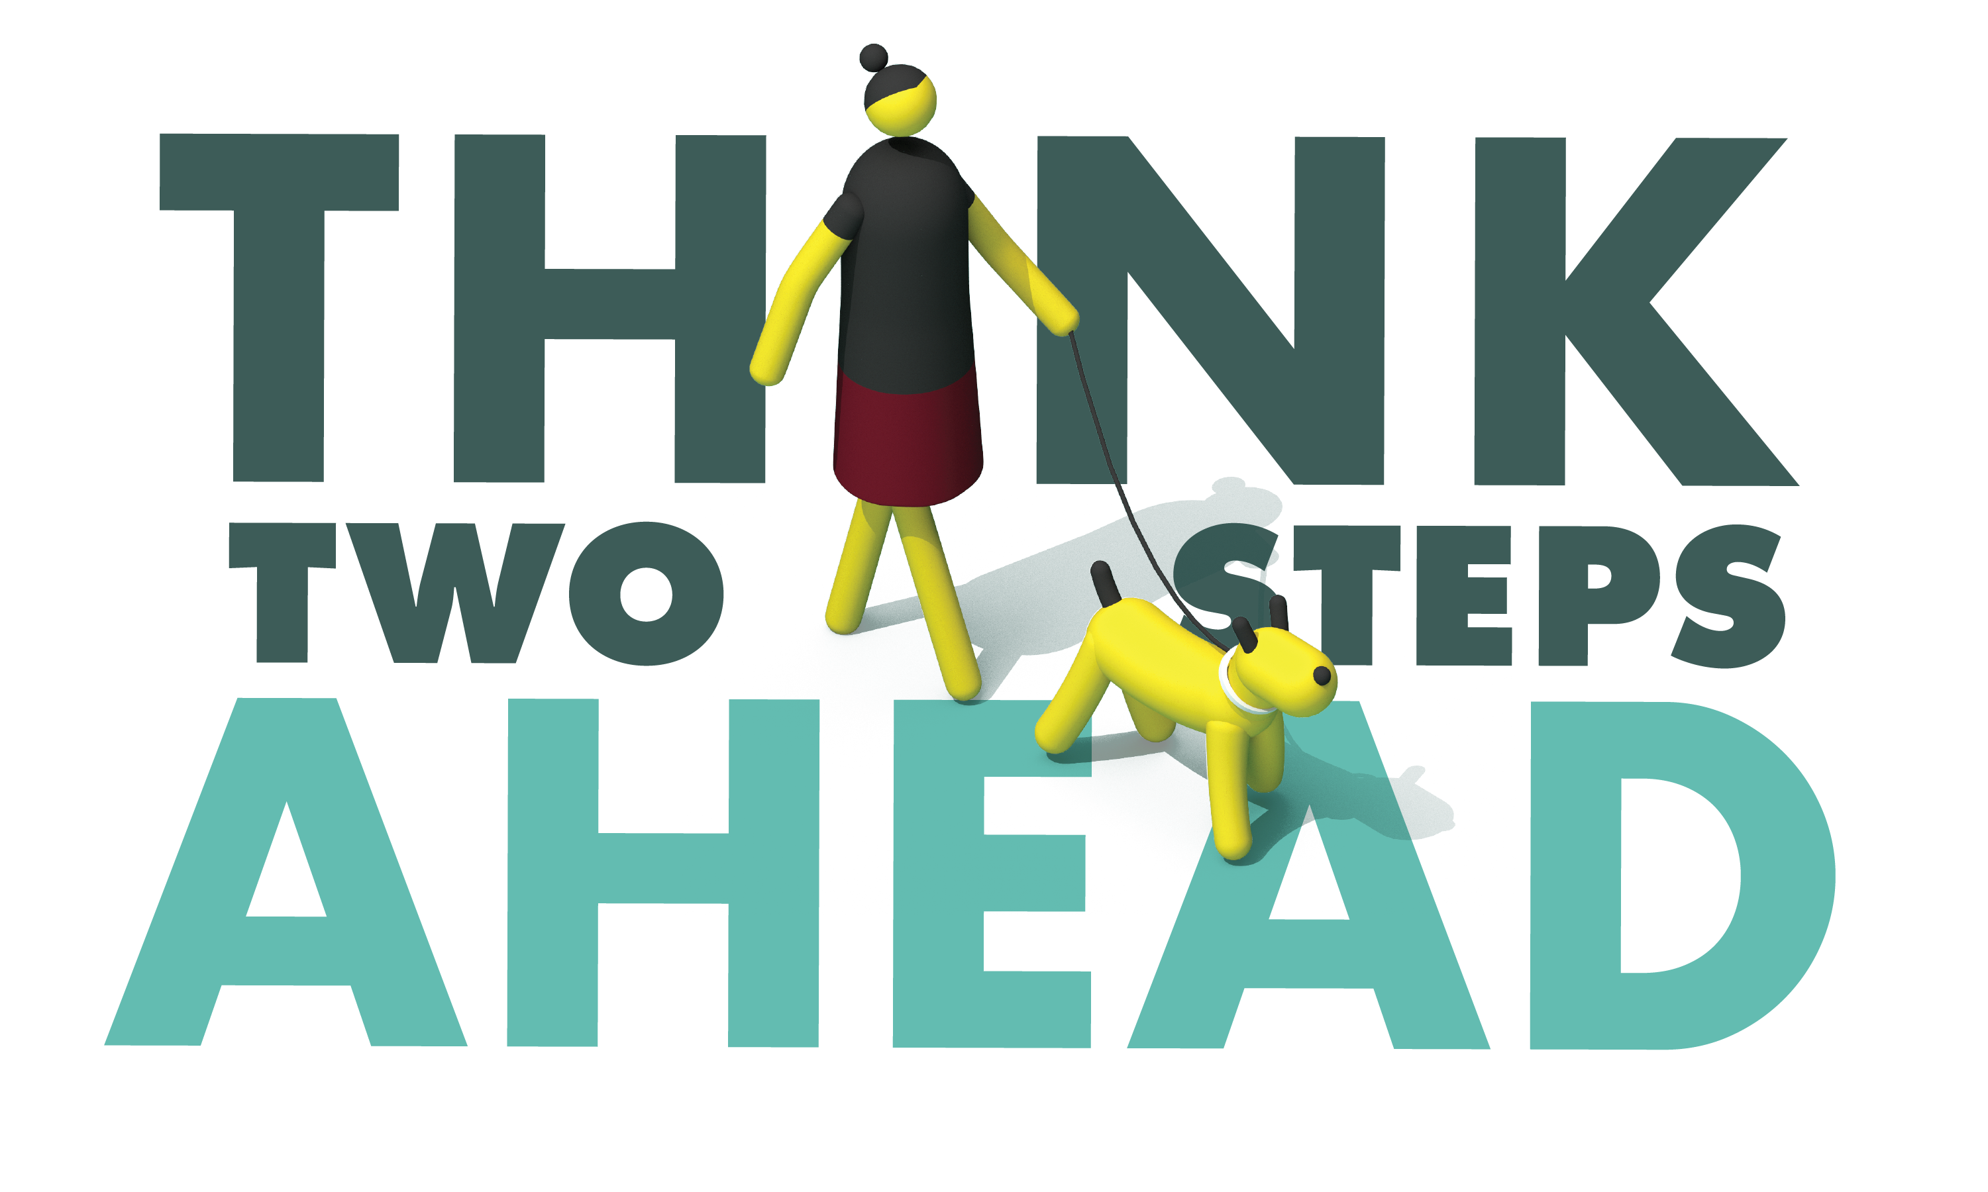
Agency Press Release or Letterhead

For Immediate Release: [Date]
Contact: Name, Phone #, Email

Bicycle and Pedestrian Safety Operation Planned for [Your City]

[Your] Police [Sheriff’s] Department will take part in a bicycle and pedestrian safety enforcement operation aimed at educating bicyclists, drivers and pedestrians on traffic laws, rules and responsibilities.

On [date and time], officers will be looking for violations made by bicyclists, drivers and pedestrians that put roadway users at risk. These violations include drivers speeding, making illegal turns, failing to yield to pedestrians in crosswalks, failing to stop for signs and signals or any other dangerous violation.

Officers will also look for pedestrians who cross the street illegally or fail to yield to drivers who have the right of way. Bike riders will be stopped when riding on the wrong side of the road, not complying with stop signs and signals, or other violation of the same traffic laws that apply to them as drivers.

Bicycle and pedestrian fatalities are rising at an alarming rate. In 2016, 138 bicyclists and 867 pedestrians were killed on California roads. Pedestrian fatalities are up nearly 33 percent from 2012, and the number of bicyclists killed are up nearly 25 percent over the past five years. In 2018 [or most recent year data is available], [Your] Police [or Sheriff’s] Department has investigated [##] fatal and injury collisions involving bicyclists and pedestrians.

“Whether you are on foot, behind the wheel or on a bike, you play a part in roadway safety,” [Your Official] said. “Understanding the rules of the road using all modes of transportation helps ensure we all get to our destination safely.”

People walking should only cross the street using crosswalks or intersections, preferably with a stop sign or signal. People on foot should also look for cars backing up and avoid darting between parked cars, make eye contact with drivers and wear bright clothing during the day and reflective materials or use a flashlight at night.

Drivers should wait for pedestrians to cross the street, avoid distractions like using a cell phone, and be courteous and patient. All bike riders are reminded to always wear a helmet; helmets are required by law for those under 18. Bike riders should always go with the flow of traffic, let faster traffic pass and use hand signals when turning or stopping.

[Your] Police [Sheriff’s] supports the new OTS public awareness campaign, “Go Safely, California.” To find out more about ways to go safely, visit gosafelyca.org.

Funding for this program is provided by a grant from the California Office of Traffic Safety, through the National Highway Traffic Safety Administration.

# # #

