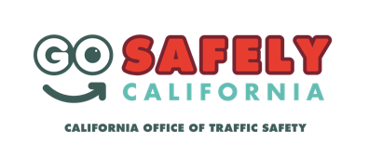
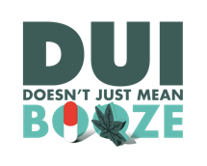
Agency logo/letterhead

FOR IMMEDIATE RELEASE: [Date]

CONTACT: [Name, Phone Number, E-mail]

Don’t Get Super Busted on Super Bowl Sunday by Driving Impaired
Law enforcement will be out looking for impaired drivers

[City], Calif. – [Your] Police [or Sheriff’s] Department is encouraging all football fans to celebrate Super Bowl LIII responsibly by not driving impaired, or letting other fans get behind the wheel when they shouldn’t.

“Have a game plan for the big game by making sure you have a safe way to get home,” [Department official name and title] said. “Your best defense against impaired driving is to use a designated sober driver.”

<<If applicable>> In an effort to flag those who choose to drive impaired, [Your] Police [or Sheriff’s] Department will increase patrols Super Bowl Sunday (Feb. 3), adding additional officers to look for drivers suspected of driving under the influence of alcohol and/or drugs.

<<If applicable>> In an effort to penalize those who choose to drive impaired, [Your] Police [or Sheriff’s] Department will be holding a DUI checkpoint on Super Bowl Sunday between the hours of XX and XX. During the checkpoint, officers will look for drivers suspected of driving under the influence of alcohol and/or drugs, as well as check for proper licensing.

“Millions of people will be watching the Super Bowl at parties and bars across the country,” [Department official name and title]. “Don’t put others at risk because you chose to break the law and drive impaired.”

[Your] Police [or Sheriff’s] Department also reminds drivers that “DUI Doesn’t Just Mean Booze.” If you take prescription drugs, particularly those with a driving or operating machinery warning on the label, you might be impaired enough to get a DUI. Marijuana can also be impairing, especially in combination with alcohol or other drugs, and can result in a DUI.

If you’re hosting a party, be a team player and have plenty of snacks and non-alcoholic drinks available for designated sober drivers. Be sure to monitor who is drinking and how they are getting home. If you plan to drink, don’t plan to drive. Even one drink can be one too many so have your sober friend be the “MVP” and get you home, use ride-share or take public transportation. Anyone who sees a drunk driver should call 911.

No matter who you are rooting for on Super Bowl Sunday, we are all on the same team when the game ends so remember to go safely.

<<If applicable>> Funding for Super Bowl Sunday enforcement is provided by a grant from the California Office of Traffic Safety, through the National Highway Traffic Safety Administration.
###
